

World Agility Open Championships

(WAO)

Rules & Regulations

*As of 11th July 2023*

1. GENERAL REGULATIONS 4

1.1 Mission Statement & Objectives 4

1.2 Event Information 4

1.3 Program of Events 4

1.4 Country Team Selection Process 4

1.5 Automatic Entry for Prior Year’s Medallists and International Champions 5

1.6 Wildcard Entries 6

1.7 Dog and Handler Eligibility 6

1.8 Jump Height Divisions 8

1.9 Measuring Dogs 9

1.10 Payment of Fees 9

1.11 Rules of Conduct 10

2. EVENTS 11

2.1 Prizes and Awards 11

2.2 Pentathlon Championship 11

2.3 Biathlon Championship 12

2.4 Games Championship 12

2.5 Team Championship 13

2.6 Junior Championship 13

3. CLASSES 14

3.1 Agility 14

3.2 Jumping 14

3.3 Speedstakes 14

3.4 Team Relay 15

3.5 Gamblers 15

3.6 Snooker 18

3.7 Bonus Class 22

4. RUNNING ORDERS & DRAW 23

4.1 Pentathlon 23

4.2 Biathlon 23

4.3 Games 23

4.4 Team 23

4.5 Draw for Height Running Order 24

4.6 General Running Order Rules 24

5. JUDGING 24

5.1 Judges 24

5.2 Course Design 25

6. OBSTACLE PERFORMANCE STANDARDS 25

6.1 A-frame 25

6.2 Dogwalk 26

6.3 Seesaw 26

6.4 Pipe Tunnel 27

6.5 Jumps 27

6.6 Wall Jump 27

6.7 Spread Jumps 28

6.8 Long Jump 28

6.9 Tyre Jump 28

6.10 Table and collapsible tunnel 29

6.11 Weave Poles 29

6.12 Start and Finish Lines 29

7. SCORING 30

7.1 Schedule of Faults and Penalties 31

7.2 Refusals 33

7.3 Wrong Courses 33

7.4 Timing & Equipment Failure 34

7.5 Interference with the Dog on Course 34

7.6 Questioning a Score 34

7.7 Collars and Leads 35

8. EQUIPMENT SPECIFICATIONS 35

9. ELECTRONIC TIMING SYSTEM 37

10. REFUSAL GUIDELINES 38

11. APPENDIX 1: GENERAL AGREEMENT FOR ENTRY TO WAO 49

12. APPENDIX 2: QUICK REFERENCE TABLES 51

1. GENERAL REGULATIONS
   1. Mission Statement & Objectives

To provide the ultimate in agility competition, showcasing the highest level of agility training, human/canine partnership, sportsmanship, and athleticism; and enabling all dogs, whether pedigreed or not, to compete in an environment that is solely focused on the sport of agility. The WAO strives to provide reasonable jump height divisions, an excellent and safe competition surface, a competitive environment that is also fun and inspiring, fairness and consistency in judging, and several varieties of contests with maximum runs to adequately test teams for all the skill sets necessary to be the best in dog agility.

* 1. Event Information

The Championships are governed by the World Agility Open (WAO) rules and regulations as stated below.

The official language of the WAO is English.

* 1. Program of Events

Individual Competitions

* **Pentathlon Championship:** 2 (two) rounds of Agility, 2 (two) rounds Jumping, and 1 (one) round Speedstakes
* **Biathlon Championship:** 1 round Jumping and 1 round Agility
* **Games Championship:** 1 round Snooker and 1 round Gamblers
* **Bonus Class:** 1 (one) round Speedstakes
* **Junior Championship:** Pentathlon, Biathlon and Games classes

Team Competition

* **Team Championship:** 2 (two) rounds of Agility, 2 (two) rounds Jumping, and 1 (one) round Speedstakes 3-Dog Relay
  1. Country Team Selection Process

Countries will be responsible for selection of their own team. A country’s team management may be an agility organisation, a committee, or an individual team manager who is approved by the WAO.

Each country’s team selection process must be *non*-*discriminatory*with regard to both handlers and dogs, and must be approved by WAO to meet this requirement. A country’s team selection process must allow for at least 1 (one) dog from each height to win its way into both the Biathlon and the Pentathlon. This must be stated in each country’s selection rules. If your team only has 1 (one) win-on spot in each height, that dog is therefore entitled to run in both events. Therefore, the WAO urges countries to consider awarding at least 2 (two) win-on spots in each height, one spot for each event.

Other positions on the country’s team may be filled at the discretion of the country’s team management.

If a team manager or coach wishes to try to qualify their own dog for their country’s team, they must abide by all published selection rules, just as any other competitor trying out for the team would.

If team managers do not want to fulfil the win on spot, they must submit the reasons for this to the WAO Organising Committee. Anyone who tries out for their country’s win on spot does so on the understanding that the management team are able to request from the WAO Organising Committee that the spot is vetoed under the circumstances that it would be extremely detrimental to the individual, their dog, the team, the sport or WAO for this person or dog to compete.

A country may set their own code of behaviour (in addition to WAO’s sportsmanship guidelines) and also define participation responsibilities for its team members (such as assisting with fundraising events). This information must be published and given to all team members. It is within the discretion of the country’s team management to dismiss a member of the team who is not complying with the code of behaviour or who fails to meet their team responsibilities. If, however, the team member being dismissed has earned a win-on spot, team management must contact the WAO Organising Committee and get the Committee’s approval before dismissing that team member.

If a country is unable to travel with their own dogs due to the laws of the host country or excessive travel times and expense, substitute dogs may be provided by the host country or another country. A country must make a request in writing to the WAO Organising Committee. Requests will be evaluated by the WAO committee on a case-by-case basis.

Each country’s team management and team selection criteria must be approved by the WAO organisational committee and will then be made available on the official WAO website: www.worldagilityopen.com.

At WAO’s request, team managers must be able to provide an accounting of all collective team fundraising income as well as all expenses collected from individual team members.

Each year only one organisation, committee, or team manager for a country may submit a team for the WAO. If there is more than one organisation, committee, or individual interested in submitting a team for the same country, then the WAO Organising Committee will review official written proposals in June prior to the following year’s competition.

* 1. Automatic Entry for Prior Year’s Medallists and International Champions
     1. Automatic Entry for Prior Year’s WAO Medallists

The WAO Gold, Silver, and Bronze medallists in each height of the Pentathlon, Biathlon, and Games events are automatically invited to the following year’s WAO to compete in the event and height for which they won a medal. (for example, the 2023 Biathlon medallists are automatically invited to compete in the 2024 Biathlon).

Medal winners will run as wildcard competitors in the relevant event(s) unless they also qualify for their country’s WAO team that year. In the latter case, they will run as an *additional* entry for their country’s team in the event for which the medal was earned. Therefore, that country will have an extra dog competing in that event. For example, if the 2023 Biathlon 300 gold medallist is from Italy, then Team Italy 2024 will run 4 (four) dogs in the 300 jump height of the Biathlon.

If the medal winner does *not* qualify for their country’s WAO team the next year, then they may **only** compete in the event in which they earned a medal the prior year. The competitor may, however, apply for one of the 7 (seven) wildcard spots in each height division (see Section 1.6). If they are awarded a wildcard spot, they can run in the class in which they medaled as well as any other individual classes.

The WAO Gold, Silver and Bronze medallists in each height of the Junior Championships are automatically invited to the following year’s WAO to compete. If they still meet the age criteria for a Junior at the subsequent WAO, then they will compete as a Junior in all events and this will mean that country can have 2 Juniors at that height. If they no longer meet the age requirements of a Junior then they will compete in all events as an additional entry for their country’s team. Therefore, that country will have an extra dog competing in that event. For example, if the 2023 Junior 300 gold medallist is from Italy, and still meets the Junior age requirements then Team Italy 2024 will be eligible to have 2 Juniors in the 300 height. If they do not meet the age requirements, then Team Italy 2024 will be eligible to run 4 (four) dogs in the 300 jump height of the Biathlon, Pentathlon and Games.

* + 1. Automatic Entry for Prior Year’s International Champions

The individual Gold medallists in each height of the championship events listed below are automatically invited to the following year’s WAO to compete as a wildcard in all individual events:

* FCI Agility World Championships: Individual
* FCI Agility Championship of the Américas y el Caribe: Individual
* Open Agility Championship of the Américas y el Caribe: Individual
* European Open: Individual
* IFCS Agility World Championships: All-Around Champion

These wildcards are in addition to the 7 (seven) dogs per jump height the WAO Organising Committee may select each year.

Anyone who is eligible to compete at WAO from sections 1.5.1 and 1.5.2, and who is not competing as part of their country team for that year, must apply to the WAO Office by 1st March to state that they wish to attend the event as a Wildcard Medallist.

* 1. Wildcard Entries

The WAO Organising Committee may select a maximum of 7 (seven) dogs per jump height (in addition to the returning WAO medal winners and international champions from the previous year, as described in section 1.5) to attend the event as individual competitors in two or three of the individual events, Pentathlon, Biathlon, and Games championships events. There will be a maximum of 5 (five) wildcards in each individual event per jump height.

There are NO restrictions or competition requirements on who applies for these positions. Therefore, any handler can apply but only partnerships the Wildcard Selection Committee believes could achieve success at the event will be offered a wildcard spot.

The 2023 WAO Gold, Silver, and Bronze medallists in each height of the Individual Agility Pentathlon, Agility Biathlon, and Agility Games events are automatically invited to the 2024 WAO to compete in the event for which they won a medal in 2023 (for example, the 2023 Agility Biathlon medallists are automatically invited to compete in the 2024 Agility Biathlon). Medal winners from 2023 will run as a wildcard in the relevant event(s) unless they also qualify for their country’s 2024 WAO team. In the latter case, they will run as an additional entry for their country’s team in the event for which the medal was earned. Therefore, that country will have an extra dog competing in that event. For example, if the 2023 Agility Biathlon 300 gold medalist is from the USA, Team USA will run 4 (four) dogs in the 300 jump height of the Agility Biathlon. Or, if the 2023 EO Large Dog winner is from Italy and he also qualifies for the WAO Italian Team, then Italy will run 4 (four) dogs in the 600 height division in the Agility Biathlon, Agility Pentathlon, and Agility Games.

If you are a competing member of a country’s team with one dog, you cannot apply for a wildcard entry with another dog.

If you are offered a reserve/alternate spot on your country’s team, you may apply as a wildcard entry. If, however, you apply as a wildcard and also accept the reserve spot, you are obligated to take the team spot if you are called in as a replacement. In that case, you cannot compete as a wildcard and any fees you have paid are forfeited. This does not apply if you do not accept the reserve spot on your team.

If you apply for your country’s team with 2 (two) dogs and 1 (one) dog makes the team but 1 (one) dog does not, you cannot decline the team spot you earned to apply as a wildcard with another dog.

Handlers must complete the wildcard entry form and submit it to the WAO Organising Committee by the Wildcard entry deadline (see the website) in order to be considered for a wildcard spot.

Once a wildcard entry is accepted by the WAO Organising Committee, the handler has the right to join the country manager’s Facebook page and attend the manager’s meeting on Wednesday.

Wildcard competitors will run under the WAO flag and must wear a WAO uniform.

* 1. Dog and Handler Eligibility

Dogs

Any dog, whether pedigreed or mixed, that is healthy and sound, trained, and over 18 months of age is eligible to participate in the WAO competition.

Bitches in season may compete at the event. They will run in their assigned position in the running order, but with a notation in the running order (such as BIS) so that both other competitors and ring crew are aware. A protective mat will be used at the start line. If a bitch comes into season during the event, the manager’s table must be notified immediately.

Dogs that are blind are not eligible.

Pregnant bitches are not eligible.

Dogs that have been exposed to any infectious disease during the 21 days prior to the event are not eligible.

All dogs are subject to an official vet check at registration and will be unable to compete if the official veterinarian deems that the dog is unfit to compete, or that competing may cause pain and/or considerable damage to the dog’s health.

The WAO Organising Committee may, at its sole discretion, require a dog to have a vet check at any time during the event.

No dog shall compete if it is taped or bandaged or in any way has anything attached to it for medical purposes, unless approved by the event’s official veterinarian.

No dog shall compete if it is not listed on the country’s official WAO Team entry form, with the exception of wildcard entries. Once the closing date for the Team Entry has passed, no additional dogs can be entered at that year’s event.

Handlers

The WAO is open to any person, without discrimination, whom acknowledges and agrees to abide by all regulations set forth by the WAO.

At the time of team selection, handlers must be a citizen of the country they represent, or have a birth certificate from that country, have parents or grandparents born in that country or have permanent resident status.

Note that a handler who competes as a representative for one country will be ineligible to compete for another country they are eligible for, for a period of 3 (three) years following the WAO competition in which they participated, and vice versa. If, however, there has been a significant change in residency and it is no longer feasible for the individual to compete in agility events on a regular basis for the country he or she formerly represented at the WAO (e.g., it’s too far to travel), the handler may apply to the WAO Organising Committee for an exception to this rule. The WAO will have the final decision in determining the residential status of the handler with regard to entry.

Exhibitors and/or attendees at the WAO are expected to behave in a civilized and sportsmanlike manner toward other people and toward their dogs. Failure to do so may lead to expulsion from the event, and future WAO championships, at the discretion of the WAO Organising Committee.

Handlers are permitted to run multiple dogs in the event (with exceptions noted for the Team Relay in Section 3.4). However, because there will likely be more than one competition ring running simultaneously, when selecting their teams, the WAO encourages each country to consider the implications to team and individual performance with regard to the rules relating to conflicting runs (see Section 4.6).

No handler shall compete if he or she is not listed on the country’s official WAO Team entry form, with the exception of wildcard entries. Once the closing date for the Team Entry has passed, no additional handlers can be entered at that year’s event.

A maximum of 3 (three) reserves may be entered for each height on the team entry form.

All dogs are entered in the WAO at their owners’ risk. While every care will be taken, the WAO and the event management will not accept responsibility for loss, damage, or injury however caused to dogs, persons, or property while at the event.

Ring crews and judges will work hard to ensure that jump bars and other equipment is properly set before each run, but the ultimate responsibility of checking the course and making sure that it is appropriate for the dog lies with each dog's handler.

**1.7.3 JUNIOR HANDLER ELIGIBILITY**

Each country may enter one junior in each height category. All handlers must have been born on or after 1st May 2005. Handlers must produce a passport or Official Government Photo documentation that states their date of birth at Check in. Failure to produce this may exclude them from the event. The junior handler must be the sole handler of the dog at this event. Junior handlers are eligible to run in the Team event.

* + 1. Policy on REfusal of Entry

The WAO Organising Committee may refuse the entry of any competitor or dog should the Committee believe that participation by the competitor or dog could be prejudicial to the sport or the event. In such case, the Committee must notify the country’s team manager in writing upon receipt of the entry.

Moreover, during the event, the WAO Organising Committee reserves the right to prohibit a competitor or dog from competing if the Committee determines that participation by that competitor or dog could be prejudicial to the sport or the event.

The burden of responsibility for the appropriateness of such action rests solely with WAO Organising Committee.

* + 1. Entry Changes & SUBSTITUTIONS FOR Injuries

After the closing date for Class Entry forms, countries may not make changes to their entry except under the following circumstances:

* WAO has made an error and the running order does not match the entry originally submitted
* A dog measures up into a higher height division
* A dog is injured
* A handler is injured

Dogs can only be withdrawn by a team manager, without the handler’s consent, as a result of injury to the handler or the dog and the withdrawal must be approved by the competition manager.

Any dog withdrawn from an event because of injury must be withdrawn from competition for the remainder of the WAO. The dog may be replaced in its runs by any other dog listed on the country’s official WAO entry form as long as the change is made, at the latest, 10 minutes after the last Official Training Session finishes. The replacement dog will have the original dog’s running order.

If a handler is injured and cannot run in an event, a substitute handler may run the original handler’s dog as long as the substitute handler was listed on the country’s official WAO entry form. The injured handler must be withdrawn from competition for the remainder of the WAO. This change must be made, at the latest, 10 minutes after the last Official Training Session finishes. The replacement handler will have the original dog’s running order.

* 1. Jump Height Divisions

The WAO will adhere to the following jump heights for all events:

|  |  |  |  |  |  |  |
| --- | --- | --- | --- | --- | --- | --- |
| Jump height NAME | Dog Height at withers | Jump Height | A-Frame Height | Ascending Spread LENGTH * | Long Jump Length | TYre Height at centER |
| **250** | 320mm & under | 250mm | 1.7m | 215-235mm | 500mm  2 boards | 400mm |
| **300** | 380mm & under | 300mm | 1.7m | 260-280mm | 600mm  2 boards | 450mm |
| **400** | 440mm & under | 400mm | 1.7m | 350-370mm | 800mm  3 boards | 550mm |
| **500** | 500mm & under | 500mm | 1.7m | 440-460mm | 1000mm  4 boards | 650mm |
| **600** | Over 500mm | 600mm | 1.7m | 530-550mm | 1200mm  5 boards | 750mm |

* Note: The length of the ascending spread is measured from the front side of the first bar to the back side of the second bar.

* Dogs may jump in a higher height division than their measured height.
* A dog may only jump at one height throughout the entire WAO competition.
  1. Measuring Dogs

All dogs jumping less than 600mm will be measured by a measuring official at registration and certified at the event. If a dog’s height exceeds the maximum allowed for the jump height which the dog has entered, the dog will be measured a second time by a second official, the Competition Manager. The decision from this measurement will be final.

If a dog is deemed to be over height, he will be excluded from competing in the height division entered. The dog may be moved up to a higher height division if desired, but the country’s entry must still adhere to the maximum of three dogs per height in each individual event; therefore, if they already have three dogs entered at the higher height, one dog would have to be withdrawn from that individual event to accommodate the dog measuring up. If a dog is deemed to be over height and does not wish to compete in individual events, it may be entered as a team dog at the new height.

There is one exception to this rule for dogs meeting the following criteria:

* It is the dog’s first WAO event
* The dog is from a country where it has been unable to get an official WAO measurement
* The dog is within 5mm of the height cut-off (e.g., 321-325mm in the 320 category).

In this instance, the country may run this dog in the higher height as an additional dog, but they may not replace the dog in the height in which he was originally entered. Therefore, they will still have the same number of total dogs in each event as per their entry form.

Dogs cannot be moved into a lower height division than they entered, even if they measure under the cut-off for the lower height division. The only exception to this will be if another dog on the team measures into a higher height division so that a direct switch can be done; for example, if a 500 dog is measured up to the 600 division but one of the 600 dogs on the team is eligible to jump 500, those two dogs may exchange places in the running order.

Dogs will be measured using official measuring devices. The dog will be placed in a standing position on a flat surface, such as a table. The measurement is taken from the perpendicular line from the top of the dog’s withers (top of the shoulder blades) to the flat surface.

Dogs must be able to be measured. Dogs that cower, that are aggressive toward the measuring official, or that are generally difficult while being measured so that an accurate measurement cannot be obtained, may be excluded from competing at the WAO.

Once a dog has an official WAO measurement, the dog does *not* need to be measured again if he competes in subsequent WAO events. If, however, a handler feels that their dog’s height has changed (due to age, for example), they may challenge their recorded height and be re-measured. They may challenge only 1 (one) time.

* 1. Payment of Fees

At the time of entry, all countries must pay their entry fees in full. Countries will be charged 1 (one) entry fee that allows them to enter all the events as stated in the rules.

Wildcards must pay their fees at the time they are offered the wildcard entry.

Countries and wildcards are responsible for paying all banking fees, PayPal charges, or credit card fees incurred in relation to sending their payments and the WAO receiving their payments.

WAO does not accept responsibility for any travel, accommodation, food, clothing, or training expenses. These expenses are solely the responsibility of each team, individual, or team management.

Any unpaid fees or shortfalls must be paid prior to the start of the event, or the country’s entry is cancelled without recourse.

* 1. Rules of Conduct

The WAO promotes dog agility pursuant to regulations consistent with international standards as a competitive, spectator sport. All competitors, officials, and event personnel shall conduct themselves in a professional and sportsmanlike manner consistent with the foregoing statement of purpose and seek to uphold, and enhance where possible, the image of the sport and WAO through such conduct and actions.

Each competitor and official at an event, including judges, members of the organising committee, and other key personnel have the responsibility to read and understand WAO rules and regulations, before entering, conducting, or officiating an event. Further, each competitor and manager acknowledge through their entry to the WAO that their participation in the event is a privilege and not a right. By virtue of their entry in the event, managers and competitors acknowledge and agree to comply with all WAO rules and regulations, and agree to accept any sanctions that may be imposed for failure to comply.

The judge has sole responsibility for determining when it is appropriate to excuse a dog and competitor from the ring based on matters related to competitor misconduct. The WAO head officials have sole responsibility for determining when an infraction should result in expulsion of a competitor, manager, or other team official from the event and/or from future events.

The following is a partial list of infractions on which the judge or WAO officials may take action:

* Abuse or harsh handling of a dog on the grounds
* Actions that may have the appearance of abuse of a dog
* Intimidation and/or impolite confrontation of judges, event officials, event helpers, or other competitors
* Continuing to argue a point with the competition manager or event manager after an official decision has been made.
* Willful misconduct or interference with another handler’s right to compete
* Language or behaviour in the ring construed to be detrimental to the spirit of good sportsmanship or that threatens to reduce the spectator appeal of the event
* Violation of procedural rules
* Violation of any rules of the property/facility where the event is being held, including ignoring no smoking area signage, failure to pick up after your dog, taking your dog into off-limits areas, damage to facility property, etc.
* Compulsive, correctional training on the grounds
* Misuse of equipment in the training ring or moving equipment in the training ring
* Creating excessive delays as a failure to respect the authority of event officials
* Wilful misrepresentation on entry forms
* Wilful misrepresentation of animals
* Dog aggression
* Failure to exercise diligence in the control of the behaviour of their dog

No drones are permitted to be flown anywhere on the WAO site at any time.

No photographs or videos may be taken during the check in process.

1. EVENTS
   1. Prizes and Awards

Rosettes and medals will be awarded to the top three placements in each jump height of each WAO event (except in the Team where the entire team receives the placement), and the following titles will be awarded:

* WAO Pentathlon World Champion
* WAO Biathlon World Champion
* WAO Games World Champion
* WAO Team World Champion
* WAO Junior World Champion

In the individual classes, the winner of each jump height in each class of an event will receive a rosette.

In the Team event, each handler on the winning team who has competed in at least 1 (one) of the 5 (five) Team classes will receive rosettes and a memento of their success.

Rosettes will be awarded to the top three placements in each jump height of the Bonus Class.

* 1. Pentathlon Championship

This is an individual event and there will be a separate competition for each jump height. Each country can enter 3 (three) dogs per height.

The Pentathlon event will consist of 2 (two) Agility runs, 2 (two) Jumping runs, and a Speedstakes class. The combined results from the five (5) classes determine the **WAO Pentathlon World Champion.** One world champion will be declared in each jump height.

There will be a standard course time and scoring is cumulative; faults (including time faults) are added to time, and the lowest score wins in all aspects of the Pentathlon. Time will be measured to 1/1000th of a second.

Based on cumulative scores after two rounds of the event, the bottom 20% of dogs in each height division (calculated from the number of dogs originally entered in the class) will *not* advance to the third round. In the event of a tie when deciding which dogs will be dropped, both dogs will progress. No dogs with 2 (two) elimination scores can move on to the third round.

Based on cumulative scores after four rounds of the event, only the top 20 dogs of each height division will be eligible to run in the final round of the Pentathlon, the Speedstakes class. In the event of a tie when deciding which dogs will move to the final round, both dogs will progress.

Each individual class will have a winner in each jump height that will be recognized at an awards ceremony. In the event of a tie in any class, the tied dogs will compete in a run-off for this award; however, only the score from each dog’s first run will be used to calculate the Pentathlon results.

In the event of a tie for the Pentathlon World Champion, the scores from Speedstakes will be used followed by Agility 2, followed by Jumping 2, followed by Agility 1, followed by Jumping 1. If there is still a tie, the dogs will compete in a run-off on the Speedstakes course.

Pentathlon Scoring

Course faults will be converted to time; for example, a 5-fault penalty will result in 5 seconds being added to a dog’s time in any Pentathlon class. So, a dog that has a clear round in 28 seconds in the Jumping 1 round and has 5 faults with a time of 32 seconds in the Agility 1 round will have a total score of 65 (28 seconds + 32 seconds + 5 faults = 65) at that point of the competition, and thus beat a dog that is clear in both runs but with a time of 32 seconds and 34 seconds, giving them a total score of 66 (32 seconds + 34 seconds = 66).

An elimination in any Pentathlon class is 50 faults plus dogs that are eliminated will be given a course time of 50 seconds, regardless of the standard course time.

The maximum course faults a dog can accumulate is 50, whether by elimination or other combined course faults. The maximum total score that can be accumulated in a single class is 100, so any dog scoring over this will have their score changed to an Elimination.

Time faults will be treated the same as course faults. For example, if the course time is 50 seconds and a dog runs clear in 51.123 seconds, his score will be 52.246 (51.123 seconds + 1.123 time faults = 52.246).

* 1. Biathlon Championship

There will be a separate competition for each jump height. Each country can enter 3 (three) dogs per height.

The Biathlon event will consist of a Jumping round followed by an Agility round. The combined results of the two classes determine the **Biathlon World Champion.** One world champion will be declared in each jump height.

Scoring is cumulative; least faults wins with time as tie breaker only, in all aspects of the Biathlon. Time will be measured to 1/1000th of a second.

Based on the scores of the Jumping round, only the top 35 dogs in each height division with a score (they cannot have been eliminated in Jumping) will advance to the Agility round. In the event of a tie when deciding which dogs will be dropped, both dogs will progress.

Each individual class will have a winner in each jump height that will be recognized at an awards ceremony. In the event of a tie in any class, the tied dogs will compete in a run-off for this award; however, only the score from each dog’s first run will be used to calculate the Biathlon results.

In the event of a tie for the Biathlon World Champion, the scores from the Agility round will determine the winner. If there is still a tie, the dogs will compete in a run-off on the Agility course.

Biathlon Scoring

Scoring is cumulative; least faults wins with time as tie breaker only. An elimination in any Biathlon class is 50 faults, plus dogs that are eliminated will be given a course time of 50 seconds, regardless of the standard course time.

The maximum course faults a dog can accumulate is 50, whether by elimination or other combined course faults.

If a handler is absent for their Biathlon Jumping run, they will be automatically withdrawn from the Biathlon Agility class and their score will be recorded as a no show.

* 1. Games Championship

There will be a separate competition for each jump height. Each country can enter 3 (three) dogs per height. The Games Championship event will consist of a Snooker round followed by a Gamblers round. The combined results of the two classes determine the **Games World Champion.** One world champion will be declared in each jump height.

Scoring is cumulative; highest number of points wins with time as tie breaker only, in all aspects of the Games Championship. An elimination in either of the Games will score 0 points and will be given 100 seconds time.

Based on the scores of the Snooker round, only the top 30 dogs in each height division will advance to the Gamblers round. In the event of a tie when deciding which dogs will be dropped, both dogs will progress.

Each individual class will have a winner in each jump height that will be recognized at an awards ceremony. In the event of a tie in any class, the tied dogs will compete in a run-off for this award; however, only the score from each dog’s first run will be used to calculate the Games Championship results.

In the event of a tie for the Games World Champion, the scores from the Gamblers round will determine the winner. If there is still a tie, the dogs will compete in a run-off on the Gamblers course.

Games Scoring

Dogs will accumulate points in Snooker and Gamblers based on the point systems described later in these rules.

If a handler is absent for their Snooker run, they will be automatically withdrawn from the Gamblers class and their score will be recorded as a no show.

* 1. Team Championship

The Team event will consist of 2 (two) Agility runs, 2 (two) Jumping runs, and a Team Relay class. The combined results from the five (5) classes determine the country that will be named the **WAO** **Team World Champions.**

A country must have at least 1 (one) dog in *each* of the 5 (five) height divisions on their entry form in order to be eligible to enter the Team Championship.

All of the country’s team members listed on the official team entry form are eligible for this event, providing the following height requirements are met: Each country will enter 5 (five) dogs in each of the first four rounds: the 2 (two) Agility rounds and the 2 (two) Jumping rounds. Each of the 5 (five dogs) must compete in a different jump height. Four scores per round will count with the lowest score in the team being dropped.

For the fifth round of the event, the Team Relay class, each country will enter 3 (three) dogs. The course will be designed so that each dog will jump its own course during the relay. The three jump heights will be 250, 400 and 500. All three scores from this round will count. Countries will choose a 250 or 300 height dog to jump at the 250 height. Countries will choose a 400 or 500 height dog to jump at the 400 height. Countries will choose a 500 or 600 height dog to jump at the 500 height. For example, a country may submit a 250 dog to jump at 250, a 400 dog to jump at 400 and a 600 dog to jump at 500. Or they could choose a 300 dog to jump at 250, a 500 dog to jump at 400 and a 500 dog to jump at 500.

Team courses will be made available the morning of the competition and team members must be nominated on the official team nomination form by the deadlines specified on the event timetable. If a country fails to submit a team roster on time, they will be unable to run in that class.

There will be a standard course time and scoring is cumulative; faults (including time faults) are added to time, and the lowest score wins in all aspects of the Team event. Time will be measured to 1/1000th of a second.

Based on cumulative scores after four rounds of the event, only the top 8 (eight) teams will be eligible to run in the final round of the event, the Team Relay. In the event of a tie when deciding which teams will move to the final round, the scores from Agility 2 will be used followed by Jumping 2, followed by Agility 1, followed by Jumping 1. If there is still a tie when deciding which team progresses to the final then both teams will progress.

Each individual class of the Team competition will have a winning team that will be recognized at an awards ceremony. In the event of a tie in any class, each team will select 1 (one) dog to participate in a run-off on that course to decide the winner of the award. However, only the score from each dog’s first run will be used to calculate the Team results.

In the event of a tie for the Team World Champion, the scores from the Team Relay will be used followed by Agility 2, followed by Jumping 2, followed by Agility 1, followed by Jumping 1. If there is still a tie the teams will compete in a run-off on the Team Relay course.

Team Scoring

Course faults will be converted to time; for example, a 5-fault penalty will result in 5 seconds being added to a dog’s time in any Team class. For example, a team that has one dog with a clear round in 28 seconds, one dog with a clear in 32 seconds, one dog with 5 faults in 30 seconds, one dog with 5 faults in 35 seconds and one dog with 10 faults in a time of 32 seconds in the Jumping 1 round will have a total score of 135. This is achieved by 28 seconds + 32 seconds + 30 seconds + 5 faults + 35 seconds + 5 faults = 135, (the 5th dogs score of 32 seconds + 10 faults = 42, will be dropped). This team would beat a team that has four clear runs but with a total time of 140 seconds.

An elimination in any Team class is 50 faults plus dogs that are eliminated will be given a course time of 50 seconds, regardless of the standard course time.

The maximum course faults a dog can accumulate is 50, whether by elimination or other combined course faults. The maximum total score that can be accumulated in a single class (excluding Team Relay) is 100, so any dog earning over this will have their score changed to an Elimination.

Time faults will be treated the same as course faults. For example, if the course time is 50 seconds and a dog runs clear in 51.123 seconds, his score will be 52.246 (51.123 seconds + 1.123 time faults = 52.246).

If any handler is nominated on the team form to run in Agility 1 or 2 or Jumping 1 or 2 and is absent for their run, the handler will earn an elimination in that class. The other team members may still run in the class and earn scores. In addition, the eliminated handler may still be nominated to run in another team class.

If any handler nominated on the official form to run in Team Relay is absent for their run, then the team will be disqualified from the Team Pentathlon event.

If an ineligible dog runs at any point in the team event, then the team will be disqualified from the event.

* 1. Junior Championship

The Junior Championship will consist of combining results from the three Individual events (Pentathlon, Biathlon and Games) to determine the **WAO Junior World Champion**. There will be a separate competition for each jump height and one world champion will be declared in each jump height.

* + 1. JUNIOR SCORING

A points system will be used where first place equals 1 point, second place equals 2 points, third place equals 3 points, scoring down to last place based on cumulative points from the three events. The Junior handler with the lowest points will be declared the **WAO Junior Champion**.

In classes where a cut off is in place and the Junior does not progress, for example an elimination in the biathlon jumping, then they will get either the points for the place they are in, or if they are in a joint place they will get that number of points.

For example in 2023 in the 500 Pentathlon, 77 dogs progressed to round 3. Places 78-84 had scores so they would get the equivalent points. Places 85-95 all had double Es, so if these were Juniors, they would all get 85 points.

If there is a tie on points the Overall Biathlon result will be used, followed by the Overall Pentathlon result. If there is still a tie the individual class results will be used to determine the winner in the following order; Biathlon Agility, followed by Pentathlon Speedstakes, followed by Pentathlon Agility 2, followed by Pentathlon Jumping 2, followed by Gamblers, followed by Biathlon Jumping, followed by Pentathlon Agility 1, followed by Pentathlon Jumping 1, followed by Snooker.

1. CLASSES
   1. Agility

The object of this class is to negotiate a full course of agility equipment. There is a minimum of 19 (nineteen) obstacles and a maximum of 22 (twenty-two).

All obstacles must be performed in the order and direction defined by the numbers. Numbers should be placed on the appropriate side of the obstacle to designate the direction the obstacle should be taken.

The Agility class *must* include the dogwalk, A-frame, seesaw, and 12 (twelve) weave poles. Other obstacles allowed: pipe tunnel, jumps, tyre, spread jumps, wall, and long jump.

* 1. Jumping

The object of this class is to negotiate a course without contact equipment. There is a minimum of 19 (nineteen) obstacles and a maximum of 22 (twenty-two).

All obstacles must be performed in the order and direction defined by the numbers. Numbers should be placed on the appropriate side of the obstacle to designate the direction the obstacle should be taken.

The Jumping class *must* include jumps and 12 (twelve) weave poles. Other obstacles allowed: pipe tunnel, tyre, spread jumps, wall, and long jump. The Jumping class *cannot* include the dogwalk, A-frame or seesaw.

* 1. Speedstakes

The object of this class is to negotiate a Jumping course that also includes an A-frame. There is a minimum of 19 (nineteen) obstacles and a maximum of 22 (twenty-two) obstacles.

All obstacles must be performed in the order and direction defined by the numbers. Numbers should be placed on the appropriate side of the obstacle to designate the direction the obstacle should be taken.

The Speedstakes class *must* include 12 (twelve) weave poles and an A-frame, both of which may be taken up to 2 (two) times each. Other obstacles allowed: pipe tunnel, jumps, tyre, spread jumps, wall, and long jump. The Speedstakes class *cannot* include the dogwalk or seesaw.

* 1. Team Relay

The object of this class is for 3 (three) dogs and 2 (two) or 3 (three) handlers to work together to perform a relay course as a team.

A handler may run 2 (two) dogs in the relay as long as there is a different handler separating that handler’s dogs. A team must run their dogs in jump height order from small to tall. So, a handler with 2 (two) dogs could run a dog at 250 height and a dog at 500 height, but they could not run a dog at 250 height and a dog at 400 height. The handler running 2 (two) dogs must have a helper to restrain the dog that goes second. That helper can be a team member or the team manager. Note that the helper’s conduct will be judged as if they are a competitor in the class.

Each dog on the team will perform a minimum of 12 obstacles and a maximum of 16 obstacles.

All obstacles must be performed in the order and direction defined by the numbers. Numbers should be placed on the appropriate side of the obstacle to designate the direction the obstacle should be taken.

The Team Relay class *must* include 12 (twelve) weave poles and an A-frame, but it is *not* required that each jump height perform both obstacles. Other obstacles allowed: pipe tunnel, jumps, tyre, spread jumps, wall, and long jump. The Team Relay class *cannot* include the dogwalk or seesaw.

The judge shall designate an area for a baton exchange between handlers. The next dog and handler to run for the team will wait in this area for their turn. The following rules apply to the baton exchange:

* The exchange must happen with both handlers and their dogs completely within the boundaries of the designated exchange box—that is, 4 (four) human feet and 8 (eight) dog feet in the box. Failure to do so will result in 10 faults for a faulty baton exchange.
* The handler waiting in the exchange area may hold or restrain their dog in any way (including gently holding the dog by the scruff of the neck or holding the dog in their arms), providing it is not deemed abusive or harsh by the judge in which case that dog will be eliminated. However, the dog must be on the ground before the baton exchange occurs or the dog will be eliminated.
* The handler waiting in the exchange area to run may have their dog on a lead. However, the lead and/or collar must be removed before the baton exchange occurs or the dog will be eliminated.
* Once a dog and handler have finished and passed the baton, they do not need to remain in the exchange box. However, they must remain in the ring or be assessed a 100 point fault. They may also restrain or leash their dogs *after* the baton exchange.
* 10 faults will be assessed if the baton is dropped or thrown, whether inside the baton exchange area or outside of it. The handler must pick up the baton before they continue on course. Failure to pick up the baton will result in the dog being eliminated. In addition, if the dog takes an obstacle before the handler has picked up the baton, the dog will be eliminated.
* If the handler leaves the exchange area without the baton, their dog will be eliminated if it takes an obstacle on the course before the handler retrieves the baton.

If a dog is eliminated, it will be given the maximum score of 50 faults. The clock is still running, so no time penalty is needed. The handler must make a sportsman-like attempt to finish the rest of the course correctly. If the judge deems that an eliminated handler is attempting to gain a time advantage by returning to the exchange area without correctly completing the course, the judge will add 50 seconds to the team’s time.

* 1. Gamblers

The goal of Gamblers is to accumulate as many points as possible within the time allotted by the judge, and then to make a strategic decision to perform one of the two short “gamble” sequences within a specified time period to earn bonus points. The competitor who earns the most points wins.

The Gamblers course is set up with the obstacles placed randomly around the ring, without specific flow. Each obstacle is assigned a point value (see table below). A handler earns those points by *successfully* completing the obstacle. An obstacle can be performed only 2 (two) times for points. There is no penalty for taking the obstacle additional times during the opening period (unless the judge deems it is loitering for the gamble as described below), but no points will be awarded.

|  |  |
| --- | --- |
| POINTS | OBSTACLE |
| 1 point | Jumps |
| 2 points | Tunnels, Tyre, Long Jump, Spread Jumps, Wall Jump |
| 3 points | Seesaw 6 weave poles |
| 4 points | A-frame |
| 5 points | Dogwalk 12 weave poles |

If they choose to do so, judges may include a bonus combination of obstacles in their Gamblers course design. The judge will determine the points earned for successful performance of this bonus combination.

Obstacles that are one-directional (that is, the seesaw, spread jumps, and the long jump) must be taken in the correct direction to earn points.

A Gamblers run consists of two parts: an opening period and a gamble period. The first part is the opening period, which has a designated course time of 30 seconds. Handlers accumulate points by successfully performing obstacles of their choice during this time period. At the end of the opening period, a whistle or horn sounds to indicate the beginning of the gamble period. During the gamble period, handlers will have a specified amount of time to complete their choice of one of two special challenge sequences that are worth bonus points.

General Gamblers Rules

* The start and finish jumps are used for timing, these obstacles will not have any point value and must be taken in the direction specified by the judge. The start jump is “live” at all times during the run. This means that if the start jump is taken after the dog has started the run, point accumulation ends and the handler should go directly to the finish jump. Going over the finish jump in either direction stops time and ends the run no matter when it is taken. Failure to take the finish jump at the end of the run will result in 100 seconds being recorded and the loss of *all* accumulated points.
* If the dog takes an obstacle before taking the start jump to start the clock, he will be eliminated.
* Once the dog has completed the gamble sequence, or if the whistle/horn sounds, the handler must direct the dog to the finish jump to stop the clock. If a dog does not stop the clock (barring a timing failure), all points are lost and 0 (zero) points will be scored.
* There will be no penalty if the dog takes additional obstacles, including running through the weave poles, on route to the finish jump.
* If an obstacle is attempted but not completed successfully (for example, taking the A-frame but missing the contact), a dog may attempt the obstacle again, as many times as necessary to complete it successfully. Alternatively, the handler may choose to move on and attempt a different obstacle without penalty.
* If an attempt at an obstacle is successful, the judge will call out the obstacle value or number of the obstacle. If an attempt is unsuccessful, the judge will call out something to indicate that you have not earned any points (for example: “No,” “Fault,” or “Zero”) and the obstacle may be reattempted immediately if the handler desires.
* If an obstacle is knocked in such a way as to alter it from its original state during the opening period it will not be available to score further points on during the opening period.
* The opening period ends when the whistle is blown or the horn sounds. This also designates the beginning of the second part of the run and time begins for the gambles. If, however, a dog is negotiating an obstacle when the horn sounds to end the opening period, points will be awarded if the obstacle has been **completed**, which is the point at which it is no longer possible for the dog to fault the obstacle (that is, landing for jumps, front feet on the ground after having touched the contact zone with at least one foot, front feet have exited a tunnel, head past last weave pole).
* When the whistle blows or the horn sounds to signify the end of the opening period, if a dog is in the process of negotiating an obstacle, which is also obstacle 1 in any gamble, but has not completed it, they will not score points for the opening section. In addition, because the obstacle has been started before the whistle or horn sounds, it must be repeated if the handler wishes to try and attempt that gamble.
* Once the whistle has blown or the horn has sounded, taking another obstacle on the way to the gamble is not faulted and is just time wasting. Once the judge deems the gamble sequence is started then they can fault. For example, the dog refuses gamble obstacle 1 and then takes another obstacle.
* There are no refusals judged during the opening period, but refusals do apply in the gamble period.
* It is at the judge’s discretion as to whether a dog may perform the same obstacle “back to back” (performing a bi-directional obstacle successfully in one direction and then immediately turning around and performing the obstacle in the opposite direction). This information will be provided by the judge in the written briefing.
* A dog may not successfully perform a contact obstacle followed by another contact, or perform a set of weave poles followed by another set of weave poles. It is at the judge’s discretion as to whether they allow weave poles to be followed by a contact obstacle or vice versa. This information will be provided by the judge in the written briefing.
* If a dog takes 2 (two) consecutive gamble obstacles in the *same* gamble in succession (one after the other) during the opening period, he will receive points for those obstacles, but will be ineligible to earn points for the gamble, even if he completes it successfully.

For example, on a gamble numbered 1-4, if you take:

#1 you cannot take #2 in any direction but you can take any other gamble obstacle.

#2 you cannot take #3 in any direction but you can take any other gamble obstacle

#3 you cannot take #4 in any direction but you can take any other gamble obstacle and so on

If the two gambles have different obstacles, then if the dog takes 2 (two) consecutive obstacles from one gamble in the opening, he may still attempt the other gamble in closing and be awarded the points if he completes it successfully. Handlers may, however, do the *same* gamble obstacle 2 (two) times successfully for points during the opening without negating their opportunity to earn points for a successful gamble. They may also do 1 (one) obstacle in gamble #1 followed by 1 (one) obstacle in gamble #2, or vice versa.

* The handler touching the dog or an obstacle (whether intentional or accidental contact) in a manner that aids the dog’s performance will result in 0 (zero) points being awarded for the obstacle.
* Stopwatches or other timing devices are allowed during the course walk-through, but may not be used as aid during the actual competition.
* The judge has the discretion to apply additional rules to the Gamblers class as long as those rules are defined in the judge’s briefing.

The Gamble

* The judge will present 2 (two) gamble sequences, one of which will be more challenging and therefore worth more points. It is up to the handler to choose (therefore, to gamble) which option to attempt.

Option 1 Gamble (less difficult) = 10 pointsOption 2 Gamble (more difficult) = 20 points

* The time allotted for the gamble period shall be determined by the judge’s discretion.
* The gamble points shall be awarded if the dog completes the chosen sequence without faults within the specified time.
* The judge may choose to incorporate a distance restriction into either of the gamble sequences, requiring that handlers direct their dogs through the sequence without being next to them. In this case, the judge will use lines on the ground to designate the handler restriction area. The handler must remain inside this marked area and not step on or over the line(s) while they direct the dog to complete the gamble. The handler is allowed to lean over the line and extend their arm over the line; they just can’t step on or over it. In addition, the dog may cross over the line(s) without any penalty.
* Although the handler must be inside the designated handler area before directing the dog to the first gamble obstacle, it is *not* necessary for the dog to be inside the handler area. When the horn sounds to end the opening sequence, the handler may immediately direct the dog to do gamble obstacle #1 regardless of the dog’s position.
* Refusals will be judged in the gamble sequence and will nullify the ability to earn gamble points.

The dog will *not* be awarded the gamble points if any of the following occur:

* The dog fails to complete the sequence within the allotted time and/or incurs faults.
* The handler steps on or over the line when a distance restriction is in effect.
* A Gamble obstacle is knocked in such a way as to alter it from its original state during the opening period.
* The handler violates the “No Loitering Rule.” Handlers must be actively attempting obstacles to earn points until the moment the horn sounds to end the opening period. If a handler stops a dog on a contact, repeats an obstacle that has already been completed twice successfully for points, or otherwise significantly hesitates while waiting for the horn to blow, will be called for loitering.
* The dog performs 2 (two) gamble obstacles consecutively within the same gamble during the opening period.

Any scenario not defined in the rules is at the judge’s discretion.

Gamblers Scoring

Points shall determine the placement of dogs. The run ends when the dog takes the finish jump and stops time. Time is a tiebreaker only.

* 1. Snooker

The object of the game is to earn as many points as possible within the course time set by the judge. Scoring is similar to the billiards game of Snooker; however, the judge may place the obstacles in the ring in any position.

The judge will design a course consisting of 3 or 4 (three or four) red jumps and an obstacle representing each of the other Snooker colours. These will be scored as shown in the table below.

|  |  |
| --- | --- |
| COLOUR | POINTS |
| Red jumps | 1 point each |
| Yellow | 2 points |
| Green | 3 points |
| Brown | 4 points |
| Blue | 5 points |
| Pink | 6 points |
| Black | 7 points |

Snooker consists of two parts. The first part, the opening sequence, allows the dog and handler to collect as many points as possible by successfully completing three red jumps, each followed by any coloured obstacle. A colour must be attempted after the last red before closing can begin. The maximum number of points available in the opening sequence is 24: 1+7+1+7+1+7. The second part, the closing sequence, requires the dog and handler to complete the coloured obstacles (#2 through to #7) in sequential order before the course time has elapsed for a maximum of 27 points.

A Snooker course should be run as follows:

* Start jump
* Red jump, any coloured obstacle,
* Red jump (different from first red), any coloured obstacle,
* Red jump (different from first and second red), any coloured obstacle,
* Yellow #2, green #3, brown #4, blue #5, pink #6, black #7,
* Finish jump

General Snooker Rules

* The start jump and finish jumps have no point values and are used for time only. They must be taken in the direction indicated by the judge. The start jump is “live” at all times during the run. This means that if the start jump is taken after the dog has started the run, it is judged as an off-course. Point accumulation ends and the handler should go directly to the finish jump. If the finish jump is taken at any time during the run the time is stopped and point accumulation ends. Failure to take the finish jump at the end of the run, or taking it in the wrong direction will result in an elimination.
* If the dog takes an obstacle before taking the start jump to start the clock, the game is over and they will be eliminated.
* Handlers should continue on course until they hear the judge’s whistle or the horn sounds to signal the end of time. The judge calling “Fault or Zero” signifies that no points have been earned, it is not an elimination.
* If the judge’s whistle blows, or the buzzer/horn goes off to signal the end of course time, or the dog finishes the closing sequence, the game is over and the handler should go directly to the finish jump to stop time. There will be no penalty if a dog takes additional obstacles on the way to the finish jump. Where Game Over is stated at any point in these rules, this means the handler should go directly to the finish jump.
* No refusals are judged in the opening sequence; therefore, the dog will get points as long as the obstacle is completed correctly. For example, if the dog misses the weave pole entry but then corrects it and finishes weaving all the poles, points will be awarded. Or, if the dog starts up the A-frame, jumps off the *up ramp*, and then gets back on the obstacle and successfully completes the A-frame, points will be awarded.
* Refusals are judged in the closing sequence.
* Once the dog enters the weaves correctly, if he does miss a pole, it is a standard fault. The judge will call “Fault or Zero” and the handler should continue on to the next red or start the closing. While the handler does not have to complete the weaves in the case of a fault, there is no penalty if he does finish the weaves.
* The course time is set per the judge’s discretion and may be different for different height divisions. The objective is for the handler to complete their opening sequence and their closing sequence (#2-#7) within this assigned time. Handlers do *not* have to take the finish jump within the designated course time. The finish jump is used solely to record total time on course in the event of a tie.
* A red jump must be successfully completed, in either direction, in order for the dog to be able to attempt a coloured obstacle of #2 through #7. Points are then awarded for successful completion of the coloured obstacle.
* Once a red jump has been completed (successfully or not) it may not be attempted again. If it is that is Game Over.
* If one of the red jumps is faulted, the handler may choose to take the 4th red (if there is one) followed by a colour before proceeding to the closing sequence. This is not compulsory and the handler can choose to go straight to the closing after the 3rd red & colour attempt.
* Obstacles that are one-directional (that is, the seesaw, spread jumps, and the long jump) must be taken in the correct direction to earn points. If the dog takes a one-directional obstacle in the wrong direction in the opening, the game is over.
* For obstacles that are bidirectional, the placement of the course number indicates the approach side of the obstacle in the closing sequence.
* Combination Obstacles: Opening - The judge may choose to set up a combination of obstacles to make up any coloured obstacle. The judge may designate the order of the combination, but may also allow the individual obstacles in the combination to be taken in any order or direction during the opening sequence. Once a combination is started, subsequent obstacles in that combination must be attempted to the point of completion, unless the dog incurs a standard fault on one of the obstacles. If this occurs (the judge will call out the fault), the handler does not have to finish the combination and may leave the obstacle to continue to the next red jump or to start the closing as appropriate. No points will be awarded and time will be wasted if the dog finishes the combination. If the dog returns to a previously completed obstacle in the combination, this is game over. If the dog takes a non-combination obstacle during the combination, this is game over. If the dog takes the combination out of a designated order or direction, this is game over.
* Combination obstacles: Closing – Any combination obstacles must be taken in the designated order and direction in the closing. If the dog faults a combination obstacle in the closing, the game is over.
* A dog is deemed to have started an obstacle once it engages with the obstacle. Once a dog engages with a coloured obstacle they must continue with the obstacle to the point of completion or standard fault.
* Snooker definition of Engaged – the dog get onto an obstacle, goes into an obstacle, touches any part of an obstacle in any way, running under any part of an obstacle, jumps over any part of an obstacle.
* Snooker definition of Standard fault – a missed down contact, a pole/brick/long jump element knocked down, breakaway tyre opening, missing a weave pole after entering correctly.
* Displaced elements will not be re-set for coloured obstacles #2-#7. e.g. Knocked jump pole or knocked long jump board. However, as long as the dog goes through the uprights on the next attempt of that coloured obstacle, points will be awarded.
* If an obstacle is demolished by handler or dog in such a way that it can no longer be attempted then no further points can be scored on this obstacle during the game.
* A judge may set a course where scoring three 7s could be deemed difficult to achieve.
* Stopwatches or other timing devices are allowed during the course walk-through, but may not be used as an aid during the actual competition.
* The judge has the discretion to apply additional rules to the Snooker class as long as those rules are defined in the judge’s briefing.

**OPENING SCENARIOS**

|  |  |
| --- | --- |
| Refusal of any red | Re-attempt obstacle and if completed correctly points will be awarded |
| Taking a red jump followed by another red jump | Game over |
| Faulting a red jump | Go directly to another red (if available) |
| Faulting any of the first 3 reds. | The 4th red is now available to score (if available) |
| Faulting the third red jump | Begin closing (#2-#7) or attempt 4th red (if available) |
| Faulting all red jumps | Begin closing (#2-#7) |
| Not going directly to another red when a red jump has been faulted, or not going to the closing sequence when the red jump faulted was the last red jump, as appropriate. | Game over |
| Taking the 4th red after successfully completing the first 3 (three) reds | Game over |
| Taking the last red jump in the opening followed by the 2-point yellow for points | Repeat #2 yellow to begin closing #2-#7 |
| Taking a coloured obstacle followed by another coloured obstacle | Game Over |
| Engaging with a coloured obstacle and then leaving before completion or standard fault | Game over |
| Faulting a coloured obstacle. | No points awarded, go to next red if any “unused” reds are remaining; otherwise must start the closing |
| Refusing a coloured obstacle after engaging with it and then attempting a different coloured obstacle | Game Over |
| Engaging with a combination obstacle and then leaving before attempting all elements (unless a standard fault incurred) | Game Over |
| Omitting an obstacle in a combination obstacle | Game Over |
| Faulting any part of a combination obstacle | No points awarded, go to next red if any “unused” reds are remaining; otherwise start the closing. You are just wasting time by continuing the combination (a faulted combination obstacle does not have to be completed before going on) |
| Refusing second or subsequent parts of a combination obstacle. | Repeat the refused obstacle to get points. If you continue on the course this is game over. |
| Taking a combination obstacle out of the judge’s specified order | Game Over |
| Combination obstacle completed correctly but dog then takes an additional obstacle in the combination | Game Over |
| Dog enters the weave poles, but misses the correct entry | Dog has engaged with the obstacle, it must reattempt to the point of completion or incurring a standard fault. If not then game is over. |
| Dog jumps off the seesaw before the pivot point, jumps off the dogwalk before the down ramp, or jumps off the A-frame before the down ramp | Dog has engaged with the obstacle, it must reattempt to the point of completion or incurring a standard fault. If not then game is over. |
| Dog enters tunnel and backs out or exits via the entry | Dog has engaged with the obstacle, it must reattempt to the point of completion or incurring a standard fault. If not then game is over. |
| Taking a one-directional coloured obstacle (e.g. spread, long jump , seesaw) in the wrong direction | Game Over |
| Refusal of a coloured obstacle where dog runs past or spins in front of obstacle | This type of refusal is not judged in Snooker opening as the dog has not engaged with the obstacle. |
| Handler touching dog or an obstacle (whether intentional or accidental contact) in a manner that aids the dog’s performance | No points awarded, go to next red if any “unused” reds are remaining; otherwise start the closing |

**CLOSING SCENARIOS**

|  |  |
| --- | --- |
| Red jump taken | Game Over |
| Obstacle(s) taken on way to finish jump after completing black #7 or after horn or judge’s whistle sounds | Not faulted, no additional points received |
| Coloured obstacle taken out of order | Game Over |
| Refusal of obstacle | Game Over |
| Coloured obstacle faulted | Game Over |
| Combination obstacle taken out of judge’s specified order | Game Over |
| Combination obstacle completed correctly but dog then takes an additional obstacle in the combination | Game Over |
| Handler touching dog or an obstacle (whether a red or coloured obstacle, and whether intentional or accidental contact) in a manner that aids the dog’s performance | Game Over |

**OPENING AND CLOSING SCENARIOS**

|  |  |
| --- | --- |
| Whistle/horn blown for time up once dog has engaged with an obstacle. | Points awarded if obstacle has been performed to completion, which is the point at which it is no longer possible for the dog to fault the obstacle (that is, landing for jumps, front feet on the ground after having touched the contact zone with at least one foot, front feet have exited a tunnel, head past last weave pole). Points awarded for a combination only if all obstacles are performed correctly and the last obstacle in combination meets obstacle completion criteria identified in the rules before the whistle/horn is blown for time. |
| Dog does not take finish jump after game ends or takes it in the wrong direction. | Elimination |
| If a jump bar is knocked on a coloured obstacle. | Provided the dog goes through the uprights on the next attempt of the coloured obstacle, points will be awarded |
| Whistle/horn blows to signal end of time | Game Over |
| Judge blows their whistle | Game Over |

Any scenario not defined in the rules will be left to judge’s discretion.

Snooker Scoring

Points shall determine the placement of dogs. Time is a tiebreaker only. The maximum amount of points that can be earned in the game is 51 points as shown below.

* In the opening sequence, a maximum of 24 points can be earned as follows:

Red jump (1 point), black obstacle (7 points)Red jump (1 point), black obstacle (7 points)Red jump (1 point), black obstacle (7 points)

* In the closing sequence, 27 points are earned if all coloured obstacles are successfully completed sequentially before maximum course time is up, as follows:

2 (yellow) + 3 (green) + 4 (brown) + 5 (blue) + 6 (pink) + 7 (black)

* 1. Bonus Class

Open to any dog that does not progress to the final round of any of the following events: 1) Gamblers in the Games championship; 2) Agility in the Biathlon championship; or 3) Speedstakes in the Pentathlon championship; will automatically be entered in the Bonus Class.

Handlers will run a Speedstakes course and will be subject to the rules of that class. Course faults will be converted to time; that is, a 5-fault penalty will result in 5 seconds being added to a dog’s time. For example, a dog that has 5 faults with a time of 32 seconds will have a score of 37 (32 seconds + 5 faults = 37).

A random running order will be generated but handlers must run strictly according to this. If a handler is running in any other class which clashes with their Bonus Speedstakes running order they will be moved to the end of the Bonus Speedstakes class. There will be no other reasons allowed for people to move their runs and it will only apply to the handler who is actually running in the other ring. This must be a genuine clash and no movement of running orders will be accepted for any runs that were over 30 minutes apart.

Eligible handlers not wishing to run the Bonus Class should let the manager’s table know they wish to withdraw as soon as the announcement is made regarding who is moving on to Speedstakes and Biathlon Agility.

Rosettes will be awarded for placements. The winner of each height will win a place in the Biathlon event for the next year. This will either be as an extra entry for their country team or as a Wildcard.

1. RUNNING ORDERS & DRAW

Countries will be randomly drawn into three groups. Then the running order in each height in each group will be randomly drawn for the first run of each event and will then proceed as described in the sections below.

* 1. Pentathlon

The running order for Round 1 will be randomly drawn for each height in each of the three country groups. A formula will then be applied to determine the running order for the next three rounds (Rounds 2 through 4). The number of dogs entered in the height division will be divided by four (4) and each handler’s running order will be moved forward by that number. For example, if 20 dogs are entered, each dog will move forward in the order by 5 positions for the next round. Once a running order gets down to 1 it restarts at the last number; in this example, 20.

|  |  |  |  |  |  |  |  |  |  |  |  |  |  |  |  |  |  |  |  |  |
| --- | --- | --- | --- | --- | --- | --- | --- | --- | --- | --- | --- | --- | --- | --- | --- | --- | --- | --- | --- | --- |
| **Dog** | **A** | **B** | **C** | **D** | **E** | **F** | **G** | **H** | **I** | **J** | **K** | **L** | **M** | **N** | **O** | **P** | **Q** | **R** | **S** | **T** |
| **Rd1** | 1 | 2 | 3 | 4 | 5 | 6 | 7 | 8 | 9 | 10 | 11 | 12 | 13 | 14 | 15 | 16 | 17 | 18 | 19 | 20 |
| **Rd2** | 16 | 17 | 18 | 19 | 20 | 1 | 2 | 3 | 4 | 5 | 6 | 7 | 8 | 9 | 10 | 11 | 12 | 13 | 14 | 15 |
| **Rd3** | 11 | 12 | 13 | 14 | 15 | 16 | 17 | 18 | 19 | 20 | 1 | 2 | 3 | 4 | 5 | 6 | 7 | 8 | 9 | 10 |
| **Rd4** | 6 | 7 | 8 | 9 | 10 | 11 | 12 | 13 | 14 | 15 | 16 | 17 | 18 | 19 | 20 | 1 | 2 | 3 | 4 | 5 |

For the final run, Speedstakes, dogs will run in reverse order of their current Pentathlon placements; for example, the dog that is in first place overall after four rounds will run last in Speedstakes.

* 1. Biathlon

The running order for Biathlon Jumping will be randomly drawn for each height in each of the three country groups. For Agility, dogs will run in reverse order of their placement in the Jumping run; for example, the dog that is in first place after Jumping will run last in Agility.

* 1. Games

The running order for Snooker will be randomly drawn for each height in each of the three country groups. For Gamblers, dogs will run in reverse order of their placement in the Snooker run; for example, the dog that is in first place in Snooker will run last in Gamblers.

* 1. Team

The running order for Round 1 will be randomly drawn. A formula will then be applied to determine the running order for the next three runs. The number of teams entered in the height division will be divided by 4 (four) and each team’s running order will be moved forward by that number. For example, if 20 teams are entered, each team will move forward in the order by 5 positions for the next round. Once a running order gets down to 1 it restarts at the last number; in this example, 20.

|  |  |  |  |  |  |  |  |  |  |  |  |  |  |  |  |  |  |  |  |  |
| --- | --- | --- | --- | --- | --- | --- | --- | --- | --- | --- | --- | --- | --- | --- | --- | --- | --- | --- | --- | --- |
| **Team** | **A** | **B** | **C** | **D** | **E** | **F** | **G** | **H** | **I** | **J** | **K** | **L** | **M** | **N** | **O** | **P** | **Q** | **R** | **S** | **T** |
| **Rd1** | 1 | 2 | 3 | 4 | 5 | 6 | 7 | 8 | 9 | 10 | 11 | 12 | 13 | 14 | 15 | 16 | 17 | 18 | 19 | 20 |
| **Rd2** | 16 | 17 | 18 | 19 | 20 | 1 | 2 | 3 | 4 | 5 | 6 | 7 | 8 | 9 | 10 | 11 | 12 | 13 | 14 | 15 |
| **Rd3** | 11 | 12 | 13 | 14 | 15 | 16 | 17 | 18 | 19 | 20 | 1 | 2 | 3 | 4 | 5 | 6 | 7 | 8 | 9 | 10 |
| **Rd4** | 6 | 7 | 8 | 9 | 10 | 11 | 12 | 13 | 14 | 15 | 16 | 17 | 18 | 19 | 20 | 1 | 2 | 3 | 4 | 5 |

The team’s running order is the same in each height division; for example, if a team runs first in the 600 height that team will also be first in all heights in that round.

When dogs are missing from a height due to team selection, the running order will move up 1 (one).

For the final run, Team Relay, teams will run in reverse order of their current Pentathlon placements; for example, the team that is in first place overall after four rounds will run last in the Relay.

* 1. Draw for Height Running Order

individual and Team

For the Individual & Teams, a random draw will be conducted by the Organising Committee prior to the event to determine the order in which the jump heights will run in the first class. The jump heights in the remaining rounds will be alternated to ensure that each height runs in a different position in each class.

If the number of entries or altered ring plans causes heights to conflict, the jump height order may be subject to change but with the intention that each height is rotated through the five positions.

Biathlon and Games

For the Biathlon and Games classes, it is intended the above formula will be used. After the first round, jump heights will be alternated in each class.

If the number of entries or altered ring plans causes heights to conflict, the jump height order may be subject to change.

* 1. General Running Order Rules

Random draws for running order will take place before the event, but will be supervised by the home country judge or a WAO official.

Handlers will be deemed late and unable to run if they are not present to walk into the ring once the previous dog has crossed the finish line.

In the event of a handler having two or more dogs in an event, WAO will endeavour to provide a gap of at least 10 dogs (9 dogs between their runs) by moving the lowest drawn dog forward in the running orders; for example, if a handler’s dogs are drawn 10th and 15th, the dog drawn 10th will be moved up to run 5th. If this does not create the required gap then the second dog will be moved backwards in the running orders to create the gap. If this still does not create the required gap, the handler will be given a 5-minute break (maximum) between dogs. For finals, handlers with 2 dogs will automatically have the earliest drawn dog moved up the running order to create this gap. If this is not possible, the handler will be given a 5-minute break (maximum) between dogs. The 5-minute countdown will start as the handler’s first dog crosses the finish line; the handler must enter the ring with their second dog before the countdown is complete. If a handler has dogs in different height divisions, and the 10 dog gap cannot be achieved, the 5 minutes will run through while the jump heights are being changed

Bitches in season will run in their assigned position in the group. Team managers must notify the WAO at check-in if they have a bitch in season competing so that a notation can be made in the running orders to alert the ring crew to put out a mat at the start line and to allow other competitors to identify bitches in season in the order. If a bitch comes into season during the event, the manager’s table must be notified immediately. Failure to notify WAO officials that you have a bitch in season when you check in, or that your bitch comes into season during the event, will result in elimination and dismissal from the event.

1. JUDGING
   1. Judges

Judges will be appointed and assigned classes by the WAO committee. It is the intention of the event to appoint judges with different course design styles in order to provide a worldwide reflection of agility. However, the WAO also wants to provide fairness and as much consistency as possible in the judging. To that end, there is a supervising judge appointed to oversee the competition judges and assist them with interpreting WAO rules.

A judge’s briefing covering rules and procedures will be held on the Tuesday before the event. Two representatives from each country (plus an interpreter, if required) and the Wildcard Manager or wildcards not representing a country will be allowed to attend the briefing.

Class course times will be announced and posted once a course is built. There will not be specific class briefings, but judges will be available at ring side during course walking for any rule clarifications. Only team managers, team coaches, and wildcards not representing a country, may ask the judge questions.

Written Gamblers and Snooker briefings will be published on the WAO website at least 2 (two) weeks prior to the event. If desired, judges may also provide written briefings for other classes or general judging comments they wish to express to the competitors.

A judge will signify the difference between a course fault and refusal by using a closed fist for a refusal and an open palm for a normal class fault.

Judging of the course will begin once the timer or judge gives the competitor permission to start. Once a dog has negotiated the last obstacle, stopping the clock, judging of the course will cease unless the performance of this obstacle is faulted; for example, bar knocked and falling.

A competitor’s conduct and behaviour toward his or her dog will be judged by the judge the entire time the competitor is within the boundaries of the competitive ring.

A judge may decide to use an assistant judge if required; for example; as a line judge in the Gamblers class, a contact judge in an Agility class, or a box judge in the Relay class. In all cases, the final judging decision will be with the class judge.

* 1. Course Design

Courses will be designed with a minimum distance of 5 metres between obstacles, using the judge’s interpretation of the large dog’s path. However, when two tunnels are placed side by side or a tunnel is next to a contact obstacle, the minimum distance does not apply.

Using the Judges interpretation of the large dog’s path, the only maximum distance specified is that contact obstacles may be no more than 8 metres from the previous obstacle. Other than this there is no maximum distance specified; however, it is recommended that courses are designed with the majority of distances between obstacles under 8 metres.

The tyre, long jump, spread and wall may only be taken once in standard classes.

Measuring the Course & Calculating Course Times

Judges are required to measure their courses to determine the course time. The course will be measured using a surveyor’s wheel and shall be measured in units of meters.

Once the course has been measured and the result is rounded up to the nearest whole number, the standard course time (SCT) can be calculated by the judge for the 600 and 500 jump heights. Ten percent (10%), with rounding to the nearest whole second, will be added to this time to set the SCT for the 400, 300 and 250 jump heights.

Course times for Snooker and Gamblers are set separately by the judge.

1. OBSTACLE PERFORMANCE STANDARDS

All obstacles must meet with the approval of and specifications of WAO as described in Section 8. Below is a description of how each obstacle must be performed and the specific faults that can occur on the piece of equipment.

* 1. A-frame

The dog must ascend the ramp in the direction designated by the judge, cross the apex, and descend the other ramp, touching any portion of the contact point with any part of his body before dismounting the obstacle. The performance of the obstacle will be considered completed when all four paws touch the ground.

* If the dog does not touch the down contact point with any part of his body, a missed contact fault will be incurred.
* Leaving the obstacle prior to beginning descent of the down ramp shall constitute a refusal.
* As the dog approaches the A-frame, he must leave the ground to ascend the obstacle before the top line of the up contact or he will incur a refusal.
* Once a dog touches the down ramp with any part of his body, if he leaves the plank before touching the contact point, he will be assessed a missed contact fault, *not* a refusal.
* Ascending the wrong ramp constitutes a wrong course.
* Running under the A-frame constitutes a wrong course except when the dog is attempting a tunnel under the contact (refusal), the contact is the next correct obstacle in sequence (refusal), and in Gamblers and the opening of Snooker.
* Missing the up-contact point shall not be faulted.
* If a dog gets on the up contact facing the wrong way this will be deemed a refusal, not an elimination.
* If the dog turns 180 degrees or more prior to touching the down ramp a refusal will be incurred. Turning 180 degrees or more once the down ramp has been touched will incur an elimination for taking the piece of equipment in the wrong direction. A refusal will be called if the dog run pasts the start of the up ramp and has to turn back 180 degrees on the ground before it can ascend.
  1. Dogwalk

The dog must ascend the ramp in the direction designated by the judge, cross the horizontal middle plank, and descend the other ramp, touching any portion of the contact point with any part of his body before leaving the obstacle. The performance of the obstacle will be considered completed when all four paws touch the ground.

* If the dog does not touch the down contact point with any part of his body, a missed contact fault will be incurred.
* Leaving the obstacle prior to touching the down ramp with any portion of his body constitutes a refusal.
* As the dog approaches the dogwalk, he must leave the ground to ascend the obstacle before the top line of the up contact or he will incur a refusal.
* Once a dog touches the down plank with any part of his body, if he leaves the plank before touching the contact point, he will be assessed a missed contact fault, *not* a refusal.
* Ascending the wrong plank constitutes a wrong course.
* Running under the dogwalk constitutes a wrong course except when the dog is attempting a tunnel under the contact (refusal), the contact is the next correct obstacle in sequence (refusal), and in Gamblers and the opening of Snooker.
* Missing the up-contact point shall not be faulted.
* If a dog gets on the up contact facing the wrong way this will be deemed a refusal, not an elimination.
* If the dog turns 180 degrees or more prior to touching the down ramp a refusal will be incurred. Turning 180 degrees or more once the down ramp has been touched will incur an elimination for taking the piece of equipment in the wrong direction. A refusal will be called if the dog run pasts the start of the up ramp and has to turn back 180 degrees on the ground before it can ascend.
  1. Seesaw

The dog must ascend the plank, cross the pivot point causing the plank to tip to the ground on the other end, and descend the plank. The plank must touch the ground before the dog leaves the obstacle (at least one paw must remain on the plank). The performance of the obstacle will be considered completed when all four paws touch the ground.

* If the dog does not touch the down contact point with any part of his body, a missed contact will be called.
* If the dog leaves the obstacle prior to touching the plank past the pivot point, with any portion of his body, a refusal will be incurred.
* As the dog approaches the seesaw, he must leave the ground to ascend the obstacle before the top line of the up contact or he will incur a refusal.
* Once the dog passes the pivot point with any part of his body, if he leaves the plank before touching the contact point, he will be assessed a missed contact fault, *not* a refusal.
* If the dog leaves with all four paws before the plank has reached the ground, it constitutes a fly-off and results in 5 faults. If the dog is deemed to leave the plank before it reached the ground *and* he misses the contact, he will only be penalized a total of 5 (five) faults.
* Missing the up-contact point shall not be faulted.
* If a dog gets on the up facing contact the wrong way this will be deemed a refusal, not an elimination.
* If the dog turns 180 degrees or more prior to passing the pivot point, a refusal will be incurred. Turning 180 degrees or more once the plank past the pivot point has been touched, will incur an elimination for taking the piece of equipment in the wrong direction. A refusal will be called if the dog run pasts the start of the up ramp and has to turn back 180 degrees on the ground before it can ascend.
  1. Pipe Tunnel

The dog must enter the end of the tunnel designated by the judge and exit from the other end of the tunnel.

* Backing out of the tunnel, exiting via the entrance, or jumping over the tunnel shall constitute a refusal.
* If the dog attempts to enter through the exit end of the tunnel, a wrong course will be assessed. If the dog’s nose breaks the plane of the tunnel entry, he has attempted to enter the tunnel; his body does not have to make physical contact with the tunnel in order to be called for a wrong course.
* Jumping over the tunnel when it is *not* the correct obstacle in the course sequence will be assessed a wrong course, unless this is done as part of the dog refusing a contact obstacle in which case it will be assessed a refusal.
* Coming in contact with the tunnel or jumping on it or over it when *it is* the next correct obstacle in sequence is explained in the diagram below.



* 1. Jumps

The dog must jump over the top bar, plank, or pole of the jump in the direction designated by the judge, crossing between the jump’s two side standards/uprights without displacing the top bar, plank, or pole on the jump.

* Jumping over the jumps wings/standards or running under the bar will constitute a refusal.
* Taking the jump from the wrong direction or running under the bar from the wrong direction will constitute a wrong course.
* If the dog knocks down a lower bar or plank on the jump without displacing the top bar, plank, or pole then there is no fault.

A refusal at a jump must be corrected before continuing on course or a wrong course fault will be assessed. If, as a result of a refusal, any part of the obstacle is displaced meaning that it can no longer be completed correctly, an elimination will be incurred.

* 1. Wall Jump

The dog must jump over the wall, passing between the 2 (two) pillars, in the direction designated by the judge without knocking any piece of the wall to the ground, including the pillars.

* Jumping up on the wall rather than trying to jump over it will constitute a refusal.
* Banking or pushing off the top of the wall in the process of attempting to jump the obstacle will not be faulted unless the dog displaces a piece of the wall.
* Taking the wall jump from the wrong direction will constitute a wrong course.

A refusal at the wall jump must be corrected before continuing on course or a wrong course fault will be assessed. If, as a result of a refusal, any part of the obstacle is displaced meaning that it can no longer be completed correctly, an elimination will be incurred.

* 1. Spread Jumps

The dog must jump over both top bars, planks, or poles of the jump in the direction designated by the judge, crossing between the jump’s 2 (two) side standards/uprights without displacing either top bar, plank, or pole on the jump.

* Jumping over the jump wings/standards, running under the bars, or failure to jump the front and back wing jumps comprising the spread as one unit will all constitute a refusal.
* Taking the jump from the wrong direction or running under the bars from the wrong direction will constitute a wrong course.
* If the dog knocks down a lower bar or plank on the jump without displacing either of the two top bars, planks, or poles then there is no fault.

A refusal at a spread jump must be corrected before continuing on course or a wrong course fault will be assessed. If, as a result of a refusal, any part of the obstacle is displaced meaning that it can no longer be completed correctly, an elimination will be incurred.

* 1. Long Jump

The dog must jump over the planks of the long jump without any of the planks falling over. The dog must cross between the front marker poles in the direction of the lowest plank, clear the span of the planks, and exit between the back marker poles.

* The dog will incur a fault if he walks on, paddles on, or steps between or on the planks. Paddling or stepping on a plank means that the bottom of the dog’s foot is placed on the equipment or on the ground and is weight-bearing. If the dog is attempting to jump the obstacle and paddles or steps on or in between the planks, it is judged as a standard fault. If the dog is making no attempt to jump, then paddling or continuously stepping or in between the planks will be judged as a refusal.
* Casual contact with a plank or a marker pole by a dog or handler, or a marker pole being knocked over (even if this causes a plank to fall) will not be faulted.
* If the dog enters and exits the jump sideways or begins the jump in the correct direction, but then exits the side of the jump, a refusal will be assessed.
* Jumping the obstacle from the wrong direction will constitute a wrong course.

A refusal at the long jump must be corrected before continuing on course or a wrong course fault will be assessed. If, as a result of a refusal, any part of the obstacle is displaced meaning that it can no longer be completed correctly, an elimination will be incurred.

* 1. Tyre Jump

The dog must jump through the tyre in the direction designated by the judge.

* Jumping between the frame and the tyre or jumping over or under the tyre constitutes a refusal.
* Taking the tyre from the wrong direction, jumping between the frame and the tyre, or jumping over or under the tyre from the wrong direction, will constitute a wrong course.

A refusal at the tyre must be corrected before continuing on course or a wrong course fault will be assessed.

If the tyre breaks while the dog is jumping/attempting to jump through the hoop, 5 faults will be incurred. Breaking the tyre is defined as the magnets needing to be reset, even if the tyre has not fully broken.

If, as a result of a refusal, any part of the obstacle is displaced meaning that it can no longer be completed correctly, an elimination will be incurred.

The tyre jump should be set up for a reasonably straight approach from the previous obstacle.

* 1. Table and collapsible tunnel

The table and the collapsible tunnel are not used in WAO competition.

* 1. Weave Poles

The dog must weave through the entire line of poles in a continuous *forward* motion, which begins by passing between poles #1 and #2 from right to left. He must then pass between poles #2 and #3 from left to right and continue this weaving pattern until he passes between the last two poles.

* *Each* incorrect entry is a refusal and will be assessed 5 faults. For example, if the dog misses the entry the first time he approaches the poles, he earns a refusal. If the handler brings the dog around to reattempt the poles, but the dog misses the entry again, he would earn a second refusal (an additional 5 faults).
* Once the dog enters correctly, the dog will only be faulted once (a 5-point standard fault) for a mistake during the duration of the weave poles.
* Failure to complete the obstacle correctly before negotiating another obstacle constitutes a wrong course.
* If the dog back weaves (that is, the dog weaves through two gates so that he takes 3 (three) poles in the wrong direction), a wrong course will be incurred.
* If the dog comes out of the poles, the dog must either re-enter the poles exactly where he came out or must re-start the weaves again. If the handler chooses to re-start the poles and the dog enters incorrectly, it is a refusal and will be faulted.

A refusal at the weave poles must be corrected before continuing on course or a wrong course fault will be assessed.

See weave diagrams on page 40 and 41.

* 1. Start and Finish Lines

Also see the section on “Electronic Timing Systems.”

Start Line

When the handler goes to the start line, a ring party member will be standing in front of the first jump. The electronic timing system will give a pre-determined start signal (a word such as “Ready” or “Go” or a beep) when the judge and timer are ready for the run to start. The ring party member will then step out of the handler’s way. The handler has 30 seconds in which to start their course run once the signal is given. Exceeding this time limit will be faulted as an elimination.

A handler may take a toy to the start line. If it is taken past the plane of the first obstacle this will incur an elimination.

After removing the dog’s lead, the handler may not place the lead or toy in front of their dog at the start line or it will be faulted for use of a training aid in the ring (elimination). The lead or toy must be placed behind the dog or to the side.

The lead or toy will be taken by a ring steward once the dog leaves the start line and placed at the exit of the ring in a designated contraband box. Only the handler may retrieve their lead or toy from this box. Anyone else removing the lead or toy from the contraband box before the dog has exited the arena will result in an elimination.

* If the handler chooses to lead out from the dog at the start line, they may not return to their dog once they have passed the plane of first obstacle. Passing back over the plane of the first obstacle will result in 5 faults, passing back over the plane and touching the dog will result in an elimination.
* Taking any obstacle before the start signal has been given will result in an elimination.
* The dog must start behind the plane of the start line. Setting up the dog past the plane of the start line will result in a 5-fault penalty.
* If the dog passes the plane of the first obstacle without taking that obstacle or commits a refusal during performance (for example, going under the bar of the first jump, jumping the wing rather than the bar, etc.), the dog will earn a 5-fault refusal in Jumping, Agility, or Speedstakes regardless of whether he has triggered the start-line sensors. In Gamblers or Snooker, 5 points will be deducted from the dog’s score. If the start-line sensors were not triggered, a video review will take place to establish the correct time for the run. Handlers must fix the run-out or refusal error and have the dog take the obstacle correctly in the direction specified by the judge or it is an elimination.
* If the handler resets the dog, without touching him, after the dog has refused the first obstacle, he will earn another 5-fault refusal penalty. If the handler touches the dog while resetting him, it is an elimination.
* A dog cannot be called for a significant hesitation refusal on the start jump. It can be faulted for running past or turning away once on approach. If one of these refusals is called then the dog will be deemed to have begun and normal judging begins.
* Handlers will be deemed late and unable to run (elimination) if they are not present to walk into the ring once the previous dog has crossed the finish line.

Finish Line

* If a team manager or another team member is at the exit of the ring, they may not act in any way to enhance a dog’s performance or that dog will be eliminated.
* Team managers and any other team personnel are **not** allowed in the outdoor rings during a dog’s run and may not pass or stand in any way that blocks the scribe and scoring tables from seeing the judge and all ring obstacles. Team personnel must walk outside of the ring to exit the entry collecting area and move to the designated finish area.
* If the handler triggers the finish-line sensors of the timing system instead of the dog in Jumping, Agility, or Speedstakes, they will be eliminated. In Gamblers or Snooker, 0 points will be scored.
* Once a dog has negotiated the last obstacle, stopping the clock, judging of the course will cease unless the performance of this obstacle is faulted; for example, bar knocked and falling.

1. SCORING

All faults and refusals will be assessed 5 (five) faults unless stated differently below.

Eliminations will be assessed 50 faults plus 50 seconds will be added for the dog’s course time. The exceptions are in the Team Relay where the dog will be assessed 50 faults but seconds will not be added for the course time, and in Games where eliminations will score 0 points and be given 100 seconds course time.

The maximum course faults a dog can accumulate is 50, whether by elimination or other combined course faults. So, for example, if a dog earns a refusal and a missed contact and then goes off course and is eliminated, his total course faults will be scored as 50.

The maximum total score that can be accumulated in a single class (excluding Team Relay) is 100, so any dog earning over this will have their score changed to an Elimination.

* 1. Schedule of Faults and Penalties
     1. Obstacle faults and penalties

|  |  |
| --- | --- |
| Missed down contact point on seesaw, A-frame or dogwalk | 5 faults |
| Flyoff on seesaw (no additional faults will be given if the dog also misses the contact zone) | 5 faults |
| Displacing a bar, planks, or pole from a jump | 5 faults |
| Knocking down any part of the wall, including the pillars | 5 faults |
| Knocking a long jump plank | 5 faults |
| Walking on, paddling on, or stepping between or on the planks of the long jump | 5 faults |
| A bar, long jump plank, wall brick or pillar falling after the dog has started the next obstacle | No fault |
| Entering the weave poles incorrectly, a refusal (assessed for each missed entry) | 5 faults |
| Popping out of the poles after a correct entry (a one-time penalty) | 5 faults |
| Breaking the tyre while the dog is jumping/attempting to jump through the hoop, | 5 faults |
| As a result of a refusal, causing any obstacle to be in a state where it can no longer be completed correctly, e.g. displacing any part of a jump, a long jump or a wall, breaking the tyre. | Elimination |

* + 1. Course handling and performance faults

|  |  |
| --- | --- |
| Refusal | 5 faults |
| Running the wrong course | Elimination |
| Back weaving | Elimination |
| Failure to complete an obstacle | Elimination |
| Failure to go through the uprights of a jump where the pole has already been knocked down | Elimination |
| 3 (three) refusals on course | Elimination |
| Dog running under a contact obstacle when the next correct obstacle in sequence is the contact or a tunnel under the contact | 5 faults |
| Dog running under a contact obstacle in any other scenario with the exception of Gamblers and the Snooker opening | Elimination |
| Dog wearing a collar | Elimination |
| Assistance from any person other than the handler that helps a dog gain an improved performance (referred to as outside assistance) | Elimination |
| Someone other than the handler removing a dog’s leash from the designated contraband box before the dog has exited the arena. | Elimination |
| Use of food or training/performance aids or devices during a run, including training/bait/bum bags and stopwatches | Elimination |
| Handler touching the equipment or the dog, whether accidentally or intentionally, in a manner that aids performance but, in the judge’s opinion, does not avoid what would otherwise be an off-course. (Incidental contact with the dog or an obstacle that does not result in saving time or avoiding other course faults is not faulted.) | 5 faults  or 0 points for obstacle in Games |
| Handler touching the equipment or the dog, whether accidentally or intentionally, in a manner that prevents an off-course | Elimination |
| Handler accidently or deliberately altering a piece of equipment so that it cannot be completed correctly. | Elimination |
| Handler going through, under, or over any obstacle (The handler may lean over an obstacle as long as they do not actually touch the obstacle, and they may break the line of the weave poles with their hand as long as they do not touch the dog or a pole.) | Elimination |
| Dog leaving the ring without finishing the course | Elimination |
| Dog fouling the ring (urinating, defecating, or vomiting) | Elimination |
| Dog cannot be caught at end of run and remains in ring, disrupting the next competitor | Elimination |
| Over standard course time: Any fraction of a second over course time will be added to the total number of faults as that fraction of time, for example, 1.492 seconds over time = 1.492 faults. | 1 to 1 ratio |

* + 1. Start and Finish Line Faults and Penalties

|  |  |
| --- | --- |
| Dog passing the plane of the first obstacle without taking that obstacle or committing a refusal during performance of the first obstacle (for example, going under the first jump, jumping the wing rather than the bar, etc.) regardless of whether he triggered the timing sensors or not. If the start-line sensors were not triggered, then a video review will determine the correct time for the run. Handlers must still fix the run-out or refusal error and have the dog take the obstacle correctly in the direction specified by the judge or it is an elimination. | 5 faults or  5-point deduction in Games |
| Handler resetting (without touching) the dog after the dog has refused the first obstacle | 5 faults or  5-point deduction in Games |
| Handler triggering the finish sensors of the timing system instead of the dog | Elimination or 0 points in Games |
| Handler setting up the dog at the start line past the plane of the first obstacle | 5 faults or  5-point deduction in Games |
| Handler leading out past the plane of the first obstacle and, instead of starting the course, returning to the dog and passing back over the plane of the first obstacle. | 5 faults or  5-point deduction in Games |
| Handler touching the dog while resetting him after the dog has refused the first obstacle | Elimination |
| Handler placing the dog’s lead or toy in front of their dog at the start line | Elimination |
| Handler taking lead or toy past the plane of the first obstacle | Elimination |
| Leading out past the plane of the first obstacle and, instead of starting the course, returning to the dog (passing back over the plane of the first obstacle) and touching the dog. | Elimination |
| Attempting or taking an obstacle before permission has been granted to begin the course | Elimination |
| Taking more than 30 seconds to start after the timing system start signal sounds | Elimination |
| Handler not present to walk into the ring once the previous dog has crossed the finish line | Elimination |

* + 1. Other Faults and Penalties

|  |  |
| --- | --- |
| Repeating obstacles deliberately to practice/train a dog will be deemed as training in the ring. The handler will be asked to leave the ring immediately. | Elimination & dismissal from event |
| Signs of aggression in the dog toward humans or other dogs | Elimination & dismissal from event |
| Unsportsmanlike conduct toward a judge, event official, event helper, or venue management | Elimination & dismissal from event |
| Directly challenging a judge regarding a call | Elimination & dismissal from event |
| Language or behaviour in the ring construed to be detrimental to the spirit of good sportsmanship or that threatens to reduce the spectator appeal of the event | Elimination & dismissal from event |
| Violation of any rules of the property/facility where the event is being held, including ignoring no smoking area signage, rearranging practice equipment, failing to pick up after your dog, taking your dog into off-limits areas, damaging facility property, etc. | Elimination & dismissal from event |
| Abusive or harsh handling in or out of the competition ring | Elimination & dismissal from event |
| Dog unfit for competition in opinion of the official veterinarian or the WAO Organising Committee | Elimination & dismissal from event |
| Failure to notify WAO officials that a handler is running a bitch in season | Elimination & dismissal from event |

* + 1. faults and penalties that apply only to team relay

|  |  |
| --- | --- |
| Dropping or throwing baton | 10 faults |
| Faulty baton exchange: Handler or dog outside the exchange area when baton is being handed off | 10 faults |
| Handler/Dog leaving the ring before the team has finished their run | 100 faults |
| Failure of a handler to run with the baton. | Elimination |
| Handler leaves the exchange area without the baton and the dog takes an obstacle before the handler retrieves the baton. | Elimination |
| Baton is dropped and the dog takes an obstacle before the handler has picked up the baton. | Elimination |

* 1. Refusals

Refusals must be corrected by the handler or an off-course fault will be incurred in addition to the 5 faults for the refusal. For example, if the dog runs by a jump and the handler does not correct this by having the dog perform the jump in the intended direction, a wrong course penalty will apply.

* 1. Wrong Courses

The dog will be assessed with running the wrong course if he in any way touches, jumps over, or goes under an obstacle out of the designated course sequence or he begins to take an obstacle in the wrong direction.

* For the tunnel, the dog is deemed to be beginning the obstacle when his nose breaks the plane of the entry; he does not have to make contact with the tunnel to be called off course.
* Touching a sandbag on an off-course tunnel without making contact with the tunnel does not constitute a wrong course when the dog is approaching the tunnel from the side; however, touching a sandbag on an off-course tunnel when the dog is approaching the tunnel straight on approach is a wrong course. Refer to diagram below.
* For the weave poles, the dog is deemed to be beginning the obstacle if his nose breaks the plane between any 2 (two) poles.
* Running under a contact obstacle when it is **not** the next obstacle in sequence is a wrong course except in the following instances: when the dog is attempting a tunnel under the contact (refusal), in Gamblers, in the opening of Snooker.

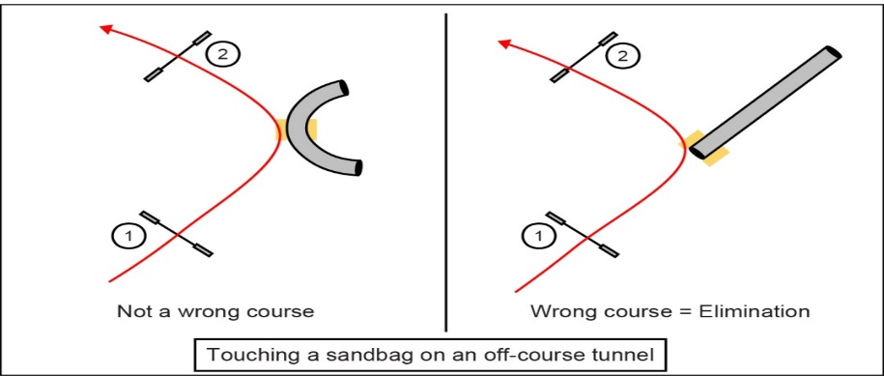

* 1. Timing & Equipment Failure

If during a competitor’s run, the electronic timing fails, then the time will be taken from a video review.

The handler is responsible for checking the course and making sure that the equipment is set correctly for their run. If there is an equipment failure during the run or it is immediately identified that an obstacle has been set incorrectly, the dog will be given a re-run. However, all faults or points from the first run will count with the exception of faults earned on the problem obstacle. If the dog ran clear the first time, he is just running the second time for time.

If a weather condition causes a jump pole to fall, a long jump plank to fall over, a brick to fall out of the wall or the tyre to open, the dog should proceed through the piece of equipment in the correct direction and continue on the course. If the judge deems the piece of equipment has become dangerous or the altered state of the equipment has caused a significant disadvantage or advantage they should ask the handler to stop. If a handler chooses to abort the run and the judge does not agree it was dangerous or was disadvantageous, then the handler will be eliminated.

If a competitor is stopped by the judge, the competitor should then leave the ring, without performing any additional obstacles, and the re-run should occur within 5 (five) minutes.

All faults or points from the first run will count up to the point of the interference. The judge must deem that the handler has made a true and sportsman-like effort in the re run, to complete the course correctly (e.g., work the contacts as the handler did in the first run) or additional faults can be added. If no faults were given and the dog faults an obstacle on the rerun before the place of the notification of the need to stop, no faults will be given.

* 1. Interference with the Dog on Course

If a spectator, animal, or something in the environment interferes with the dog on course in a manner that is not considered normal for a large international spectator event, and the judge deems that interference to have had a detrimental effect on the dog’s run, the judge may offer a re-run.

The judge will try to stop the handler as soon as the interference occurs. The competitor should then leave the ring, without performing any additional obstacles, and the re-run should occur within 5 (five) minutes.

All faults or points from the first run will count up to the point of the interference. The judge must deem that the handler has made a true and sportsman-like effort to complete the course correctly (e.g., work the contacts as the handler did in the first run) or additional faults can be added.

* 1. Questioning a Score

what can be questioned?

* Scribe mistakes and any other clerical errors
* Incorrect application of WAO rules that does not involve a judgement call; for example, if the judge signals a fault for an up contact on the dogwalk (which is not a fault under WAO rules) that call can be questioned.

Contact calls may not be challenged.

Refusals may not be challenged.

WHEN can a score be questioned?

The results of the last 5 (five runs) will be displayed on a computer monitor or on posted scribe sheets at the ring exit. This information must be checked by the team manager and the competitor within 5 (five) minutes of the conclusion of the run. Any mistake must immediately be brought to the attention of the WAO helper who is supervising the ringside results area or the Ring Manager. The helper will check the score and correct any clerical error. If the problem with the score is an incorrect application of a WAO rule, the helper will notify the ring manager to stop the ring as quickly as possible so the problem can be discussed with the judge. The decision of the judge is final.

Once the scribe sheet has been removed from the computer monitor or the posting area, it may no longer be questioned for any reason.

Results will be verified and printed at the close of the class and posted online, with a copy available at the team manager’s table.

Competitors and team officials cannot directly challenge a judge in any instance or they face dismissal from the event.

Competitors and team officials who use social media to dispute a judge’s call or cast aspersions about the results of the event may be dismissed from the event and banned from future events as seen fit by the WAO organising committee.

* 1. Collars and Leads

Dogs must not wear any type of slip or half-slip lead, head collar, muzzle, harness, or collar while competing.

Stop pad protectors may be worn by a dog if approved by the event veterinarian. Handlers that run dogs with stop pad protectors do so at their own risk.

Electric collars may not be used anywhere on the WAO grounds. Citronella spray collars or similar devices are not permitted within 50m (approx. 164+ feet) of a competition ring. Handlers in breach of this rule will be asked to leave the event.

1. EQUIPMENT SPECIFICATIONS

The following obstacles meet with the approval of WAO. A 1.5cm variable on measurements will be accepted except for jump height cups and weave pole distances. The event equipment supplier must be approved by the WAO committee and will be publicized before the event.

Wing Jumps

Width of wings: 400mm minimum

Length of poles: 1.20m minimum. 1.5m maximum

Plank length: 1.20m minimum. 1.5m maximum

Pole thickness: 40mm minimum, 51mm maximum

Pole weight: 1.0-1.2 kg

The heights available must be: 200mm, 250mm, 300mm, 400mm, 500mm, and 600mm

The top bar or plank must be easily displaced by the dog

Wall Jump

A wall should have displaceable units on the top

The width of central jumping area is a minimum of 1220mm, excluding pillars

Depth of wall is 200mm.

Pillar height is a minimum of 1100mm and 350mm square width

Displaceable blocks and tiles on top no greater than 200mm wide

The heights available must be: 250mm, 300mm, 400mm, 500mm, and 600mm

Spread Jump

A spread jump is made by placing two wing jumps together with the poles set at ascending heights

The heights available must be: 200mm, 250mm, 300mm, 400mm, 500mm, and 600mm

The back bar of the spread will be set at the same height as the regular jump height. The front bar of the spread will be set at least one jump height lower than the back bar for all height divisions.

Length of spread: Defined in jump height table. The length will be measured from the front side of the front bar to the back side of the back bar, on a flat trajectory.

TYre

The tyre consists of a hoop mounted in a rigid frame. The height of the hoop must be adjustable.

The hoop must be of a consistent shape and constructed using an impact-absorbing material.  The hoop should swing open in a saloon doors fashion, thereby having no pieces fall to the ground. Both sides must have an ability to swing open 100 degrees or more from the closed hoop position. The hoop must not be self-return but manually reset.  The two halves should be held in place at the top and bottom of the hoop using magnets with a 5KG pull strength.

Diameter of hoop aperture: 510mm minimum

The frame must not be higher than the top of the hoop when the hoop is set at maximum height

The hoop must be closely coupled to the frame (that is, not suspended by a chain or other mechanism) and secured in such a way that dogs cannot knock the obstacle over from either direction.

The heights available, measured in a straight line from the ground to the center of the hoop, must be: 400mm, 450mm, 550mm, 650mm, and 750mm. If the tyre at the event cannot be lowered safely to the correct 250mm height, it will be set at the 300mm jump height.

Long Jump

The long jump is comprised of two to five boards:

250mm: 2 boards

300mm: 2 boards

400mm: 3 boards

500mm: 4 boards

600mm: 5 boards

Length of boards: 1000mm minimum

Height of first board: 150mm

Height of fifth board: 280mm

Depth of each unit: 150mm

Maximum length of jump: Defined in jump height table

Marker pole height: 1.20m minimum

The marker poles should be placed at each corner and should not be attached to any part of the obstacle.

Pipe Tunnel

Diameter: 600mm minimum

Length: 3.0m to 6.0m

Distance between wire supports (the pitch): 101mm to 200mm with a mean of 175mm

Material must be made of PVC and be at least 620 grams

Note: Tunnels that are 3.0m or 4.0m long may only be used in a straight configuration; no bends.

Weave Poles

The number of poles should be six or twelve. The poles must be rigid construction.

Pole height: 850mm to 1.1m maximum

Pole diameter: 30mm to 40mm

Distance between poles: 600mm

Maximum height of base: 10mm

A-Frame

The A-frame is constructed of two ramps, hinged at the apex

Length of ramp: minimum 2.65m, maximum 2.75m

Width of ramp: 900mm which may be increased at the bottom to 1150mm maximum

Height at apex: 1.7m

The last 1.06m of the bottom of each ramp is a contact point and must be a different colour

Each ramp will have a non-slip surface and anti-slip slats at regular intervals of approximately 25cm but not within 10cm of the start of the contact area.

Slat height: 5mm-10mm

Slat width: 20mm-35mm

Seesaw

The seesaw consists of a plank firmly mounted on a central bracket

Length of plank: 3.65m minimum to 3710mm maximum

Width of plank: 300mm

Height of center of plank: 60cm measured from the ground to the top of the plank

Height of end of plank: 1180-1210mm measured from the ground to the top of the plank

The last 900mm of each end of the plank is a contact point and must be a different colour

The plank will have a non-slip surface, but must not have anti-slip slats

The seesaw must tip between 2-3 seconds when a weight of 1 kilo is placed in the center of the down contact area of the obstacle.

Dogwalk

The dogwalk consists of a central plank with firmly fixed planks at either end

Length of planks: 3.65m minimum to 3710mm maximum

Width of plank: 300mm

Center plank height: 120cm to 130cm maximum measured from the ground to the top of the plank

The last 900mm of the bottom of each ramp is a contact point and must be a different colour

Each plank will have a non-slip surface, with the two end planks also having anti-slip slats at intervals of approximately 250mm, but not within 100mm of the start of the contact area

Slat height: 5mm-10mm

Slat width: 20mm-35mm

1. ELECTRONIC TIMING SYSTEM

A timekeeper shall be assigned to monitor and reset the electronic timing system under direction of the judge.

Time shall be measured to 1/1000th of a second.

Sensors should be positioned to form a start and finish line at a position on or immediately in front of the first obstacle and on or immediately beyond the last obstacle. The placement of the sensors must not impede the performance path of handler or dog.

The course distance is measured from the start and finish lines as defined by the sensors.

* If the dog passes the plane of the first obstacle in the process of refusing it, therefore failing to trigger the timing sensors, a video review will be used to establish the correct time for the run. In addition, for a Jumping, Agility, or Speedstakes course the dog will earn a 5-fault refusal penalty plus a 5-second time fault penalty. For Gamblers and Snooker, 5 points will be deducted from the score earned.
* If a dog runs under the bar of the last jump, a refusal will be assessed. If he trips the sensors in doing so, a video review will be used to establish the correct time for the run.
* If a dog takes the last jump out of sequence, a wrong course will be assessed. If he trips the sensors in doing so, the timer will press the restart button so that the clock continues to run. Time will not stop until the dog has completed the jump in its proper numbered sequence and passed through the sensors again. If the electronic timer fails to be restarted, then the manual timer will be used for the official time.
* If the dog runs past or refuses the last jump, a refusal will be assessed. The clock will continue to run until the dog completes the last jump and goes through the sensors to stop time. If the dog leaves the ring without completing the last jump of a Jumping, Agility, or Speedstakes course, he has failed to complete the course and will be eliminated.
* If the dog takes the last jump and goes under or over the timing sensors, failing to trigger them and stop the clock, then a video review will be used to establish the correct time for the run.
* If a handler triggers the finish sensors instead of the dog in a Jumping, Agility, or Speedstakes course, an elimination will be incurred. In Gamblers and Snooker, 0 points will be scored. If the handler triggers the start sensors, then time will keep running and will not be restarted.

Course Design Considerations

* Only single jumps may be used for the start obstacle and the finish obstacle.

1. REFUSAL GUIDELINES

A refusal is defined as:

* Improperly performing an obstacle, as described in the “Obstacle Performance Standards”
* Running past the obstacle to be performed
* Significant hesitation in front of an obstacle
* Turning back from an obstacle after beginning an approach

**Approach is defined as “the dog is actively moving directly towards the obstacle”.**

**Improperly performing an obstacle, as described in the “Obstacle Performance Standards”**

A dog is subject to a refusal regarding obstacle performance standards once they are completely on or in an obstacle with all four feet, or all four feet have left the ground, for a jumping obstacle. A dog that enters the tunnel, steps onto a contact, or enters the weave poles and then stops with fewer than four paws on or in the obstacle, is subject to a refusal call as described in the points below.

Once on a contact with all four feet, the dog may stop or walk backwards (providing it does not turn 180 degrees) without penalty as long as it exits the obstacle correctly. If, however, the dog dismounts the obstacle before the defined refusal point he will be given a refusal fault and is then subject to additional refusals on the re-approach to the obstacle. If the dog turns 180 degrees or more prior to the defined refusal point, a refusal will be incurred. Turning 180 degrees or more once the dog has passed the defined refusal point, will incur an elimination for taking the piece of equipment in the wrong direction. If a dog gets on the up contact facing the wrong way this will be deemed a refusal, not an elimination.

Once in a tunnel with all four feet, the dog may stop or reverse direction without penalty as long as it exits the obstacle correctly. If, however, the dog backs out of a tunnel, (comes back out of the entrance end of the tunnel and one foot touches the ground), he will be given a refusal fault and is then subject to additional refusals on the re-approach to the obstacle.

**Running past the obstacle to be performed**

The refusal line is defined as the front plane of an obstacle, except in the case of contacts and weaves described below. The refusal line only becomes active when the judge deems that the dog has started to approach the obstacle. A refusal cannot be called until the dog is on the take-off side of a jump or the entrance side of a tunnel entrance, and on approach.

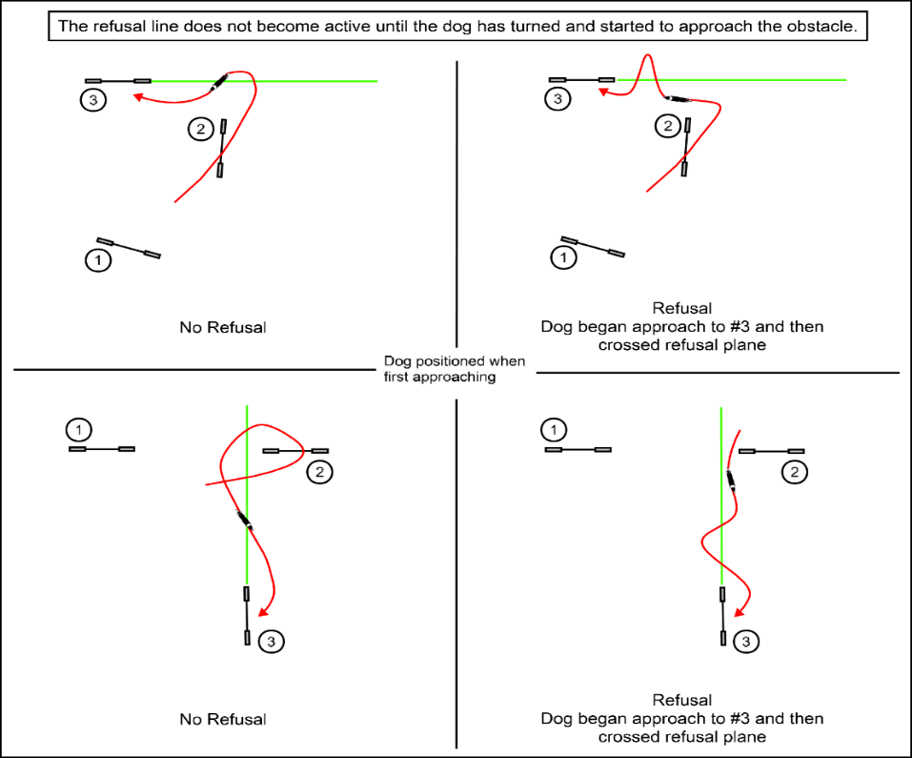

**Refusal Line for Contacts**

In regard to contacts, a refusal for running past is defined as the dog having to turn back and approach a 2nd time.

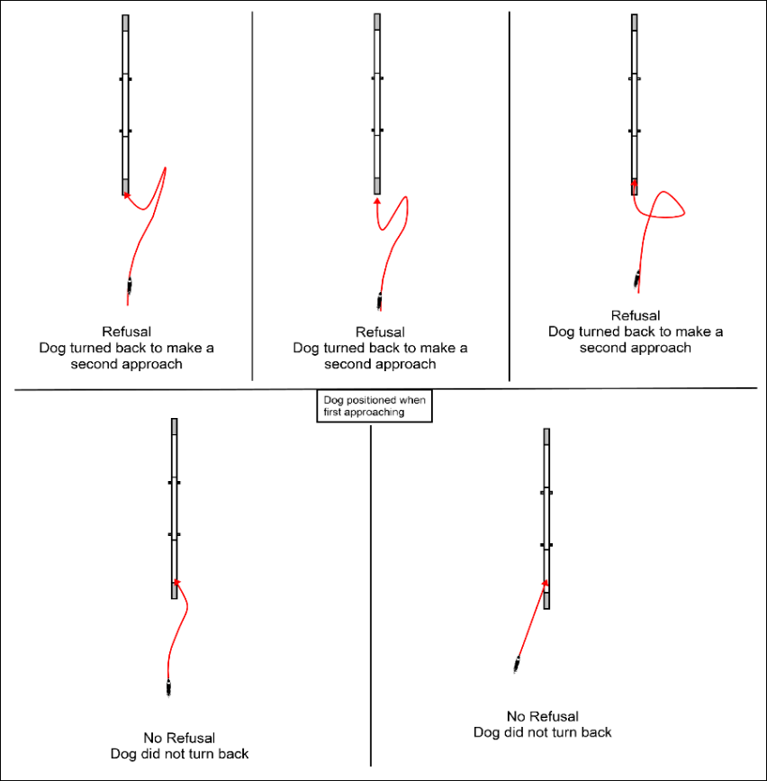

As the dog approaches the obstacle, he must leave the ground to ascend the obstacle before the top line of the up contact or he will incur a refusal.

**Refusal Line from weave entries with shallow entries**

The weave pole refusal plane varies based on which side of the weaves the dog is approaching: “on-side” or “off-side.” The dog must make the entry by pole #2. A refusal for running past is defined if the dog has to turn back and approach a 2nd time.

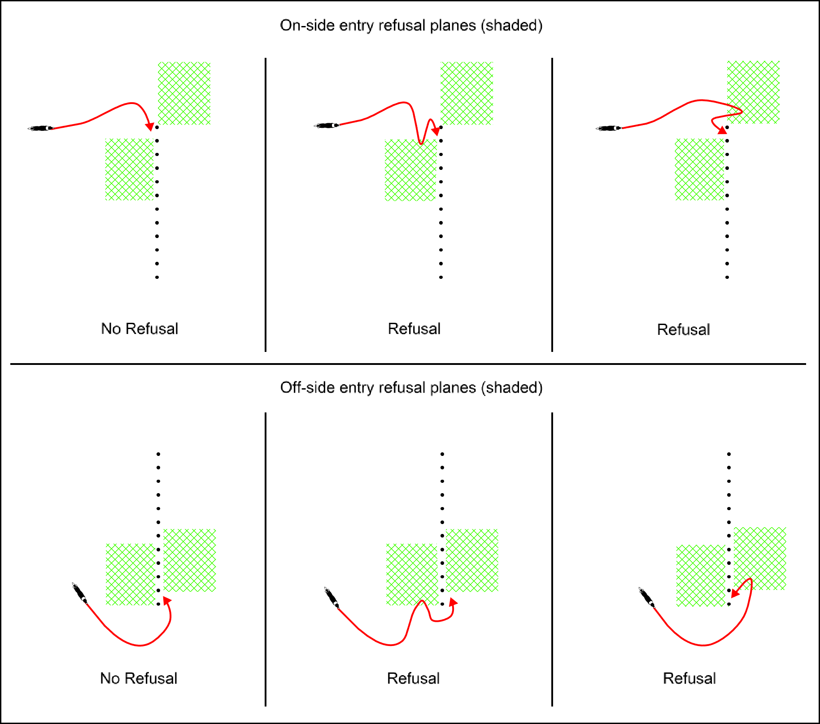



**Refusal guide for weaves with extreme entry angles**

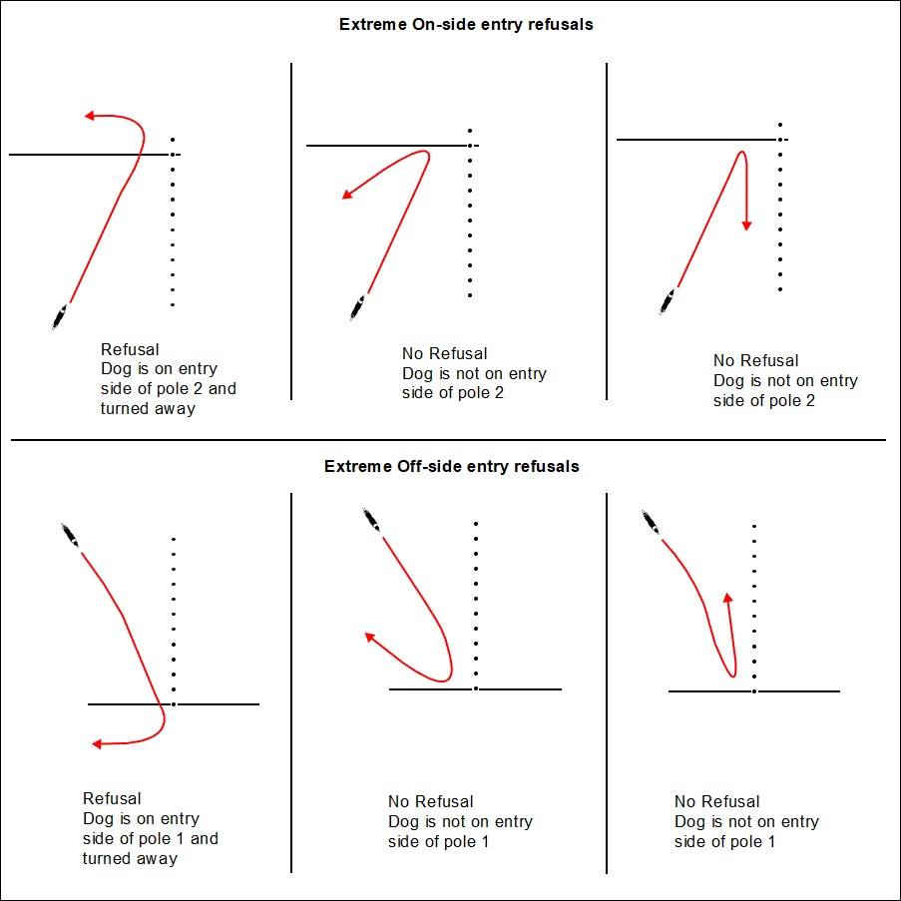

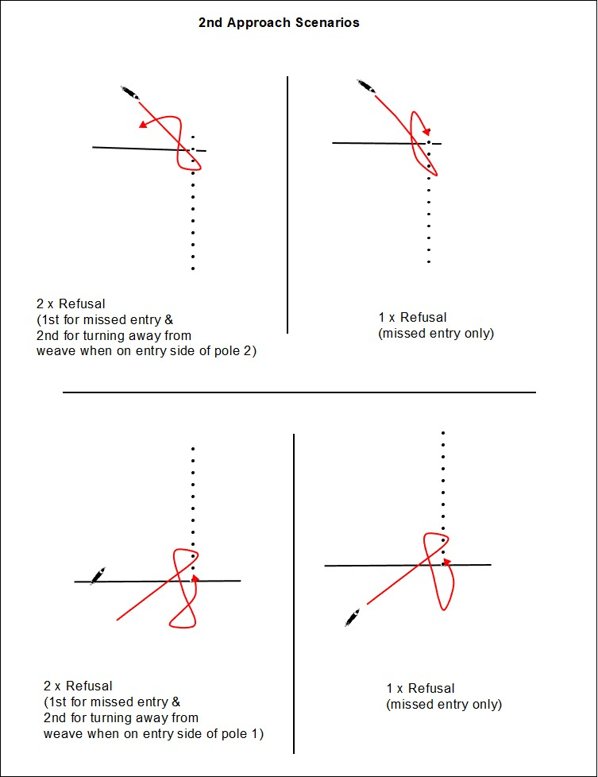

**Run by of obstacle where they do not cross the front plane.**

Where a dog has approached an obstacle on an angle, such as a slice jump, then the dog is deemed to have run past and will incur a refusal if the dog has to turn back and approach a 2nd time.

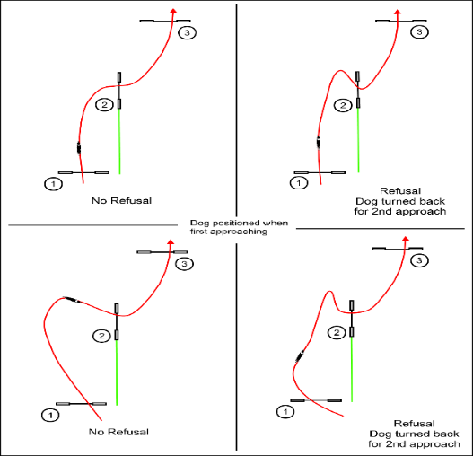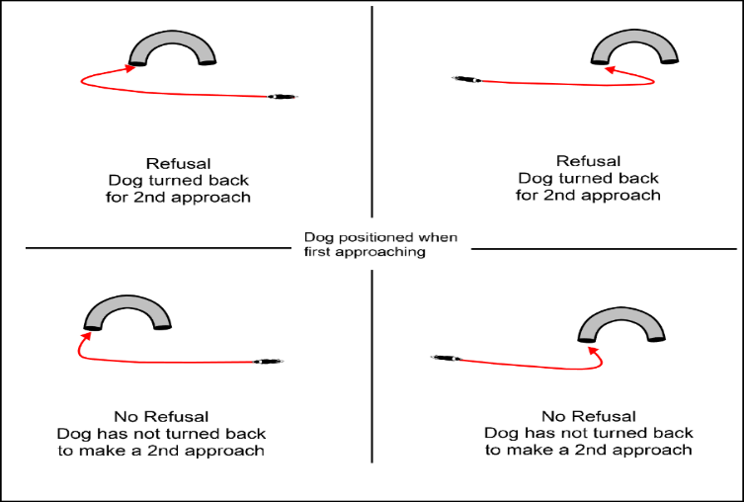

**Rule of Thirds**

To help judges determine when a spin, a hesitation, or a deviation off line is considered a refusal, we use the rule of thirds.

Visualise the path of the dog between 2 (two) obstacles and break it into 3 (three) sections:

* In the first one-third the dog is landing or leaving the prior obstacle and orienting toward the next obstacle. A refusal cannot be called in this section.
* In the second one-third, the middle ground between two obstacles, only a significant deviation off the dog’s line to the next obstacle can be called a refusal.
* In the final one-third, closest to the next obstacle and the final approach, any spin, hesitation, or deviation off line is a refusal. A significant hesitation is as long as it takes the judge to say the words, “significant hesitation.”



A deviation from their line is defined as the dog changing from their approach angle, to be at approximately 90 degrees or more of a turn away from the obstacle with their body, as ruled by the judge. A dog looking over their shoulder but continuing to move forward in the same direction should not be called a refusal.

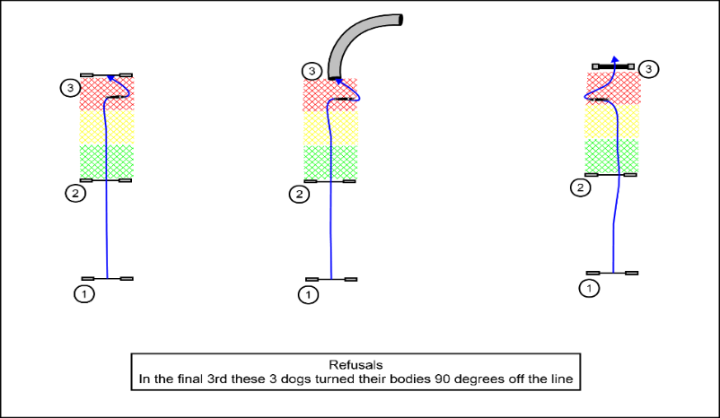 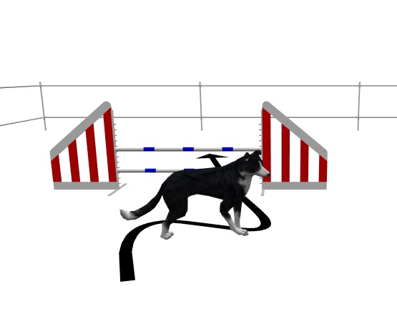

Diagrams above demonstrate Refusal due to a deviation in final third as the dog has turned its body 90 degrees off the approach line.

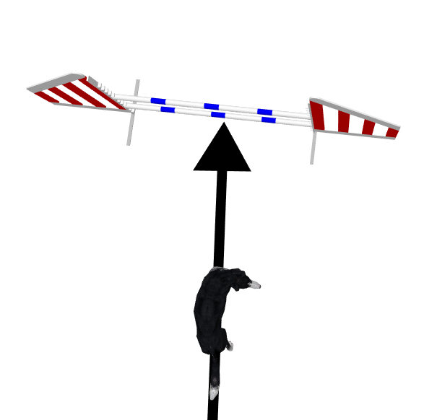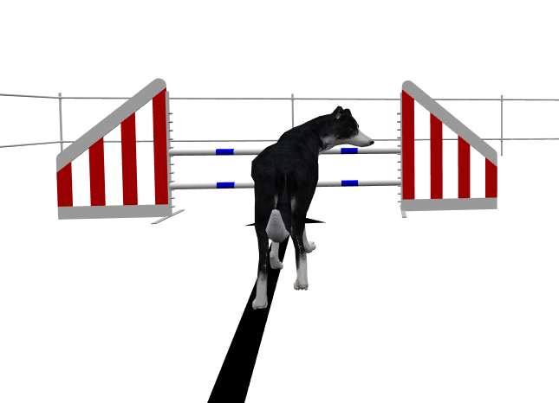

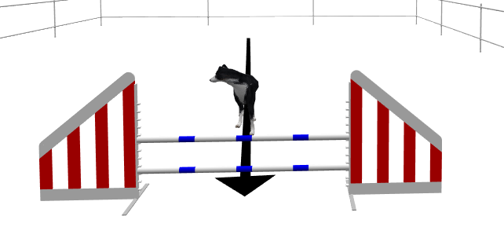

The three diagrams above are not refusals as the dog has not turned its body 90 degrees off the line of approach and has just looked away.

**Examples of Rule of Thirds**

example 1

example 2

**Back Side or blind entrance approaches**

For a refusal to be called, the dog must be on the take-off side or entrance side of a piece of equipment. Once a dog has passed the line of the obstacle with any part of his body and then performs a behaviour that constitutes a refusal, a fault should be called. (For the weaves please refer to the above diagram due to the multiple sides that can be considered the entry side)

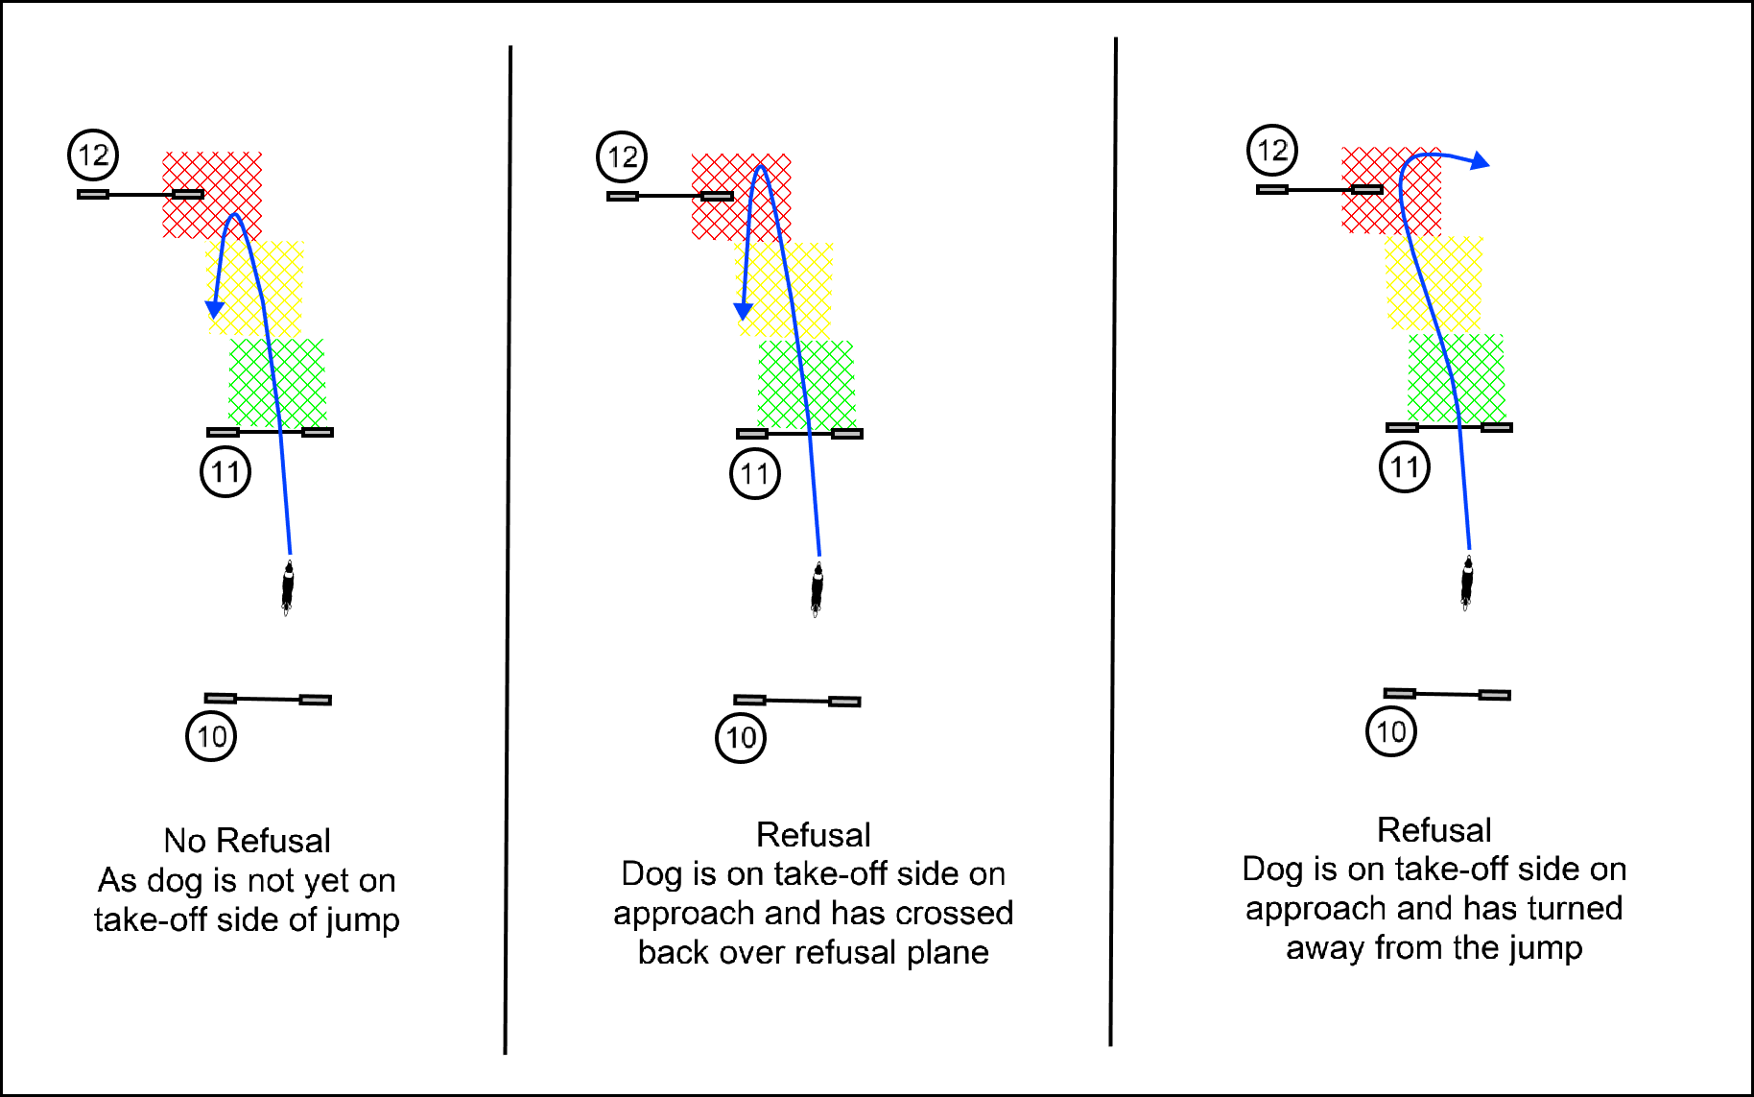

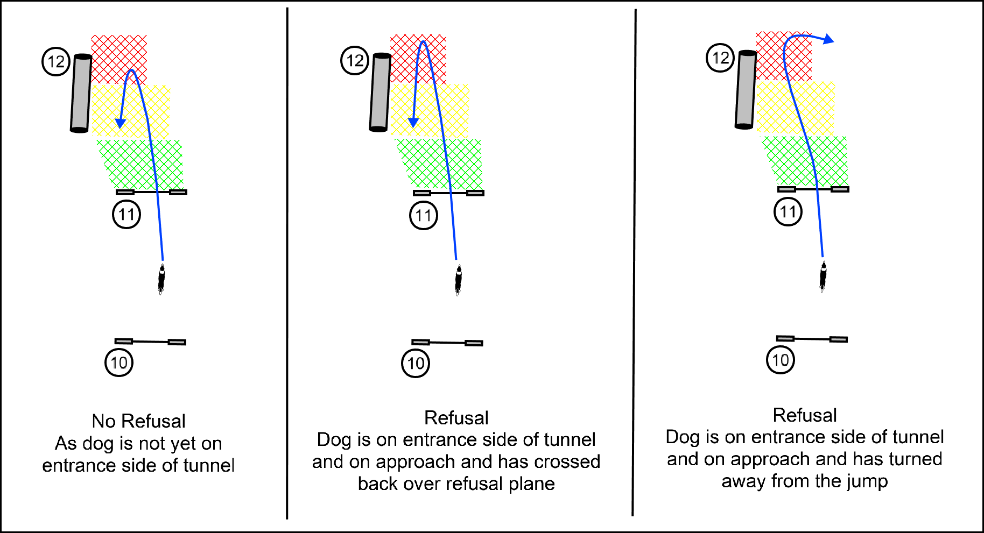

If on a blind approach the dog makes contact with the tunnel side or tunnel holders and then turns away or jumps over the tunnel, a refusal will be called.

**Additional Refusal examples and clarification**

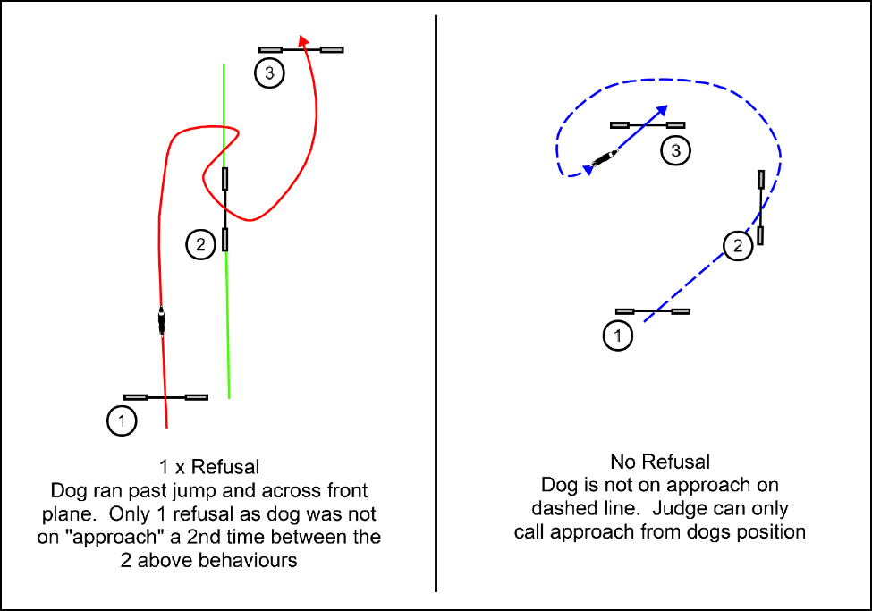

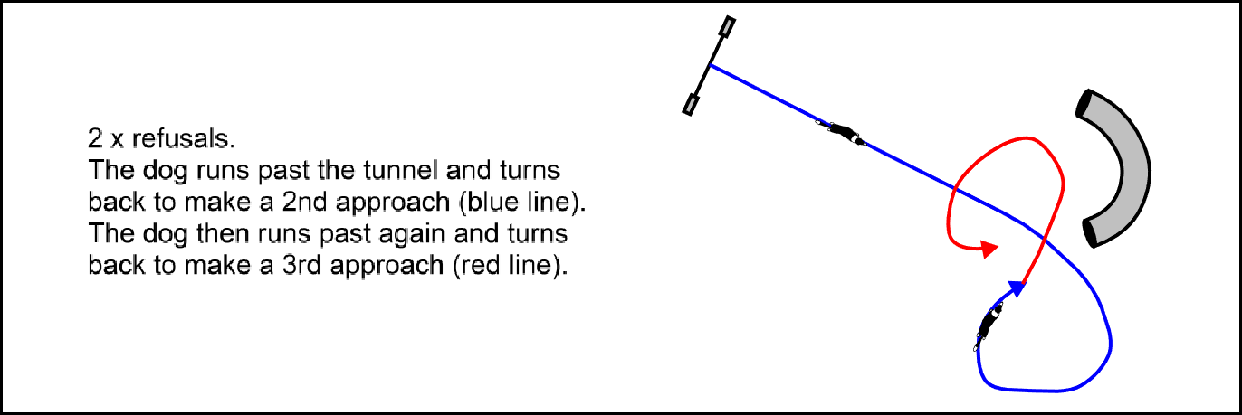

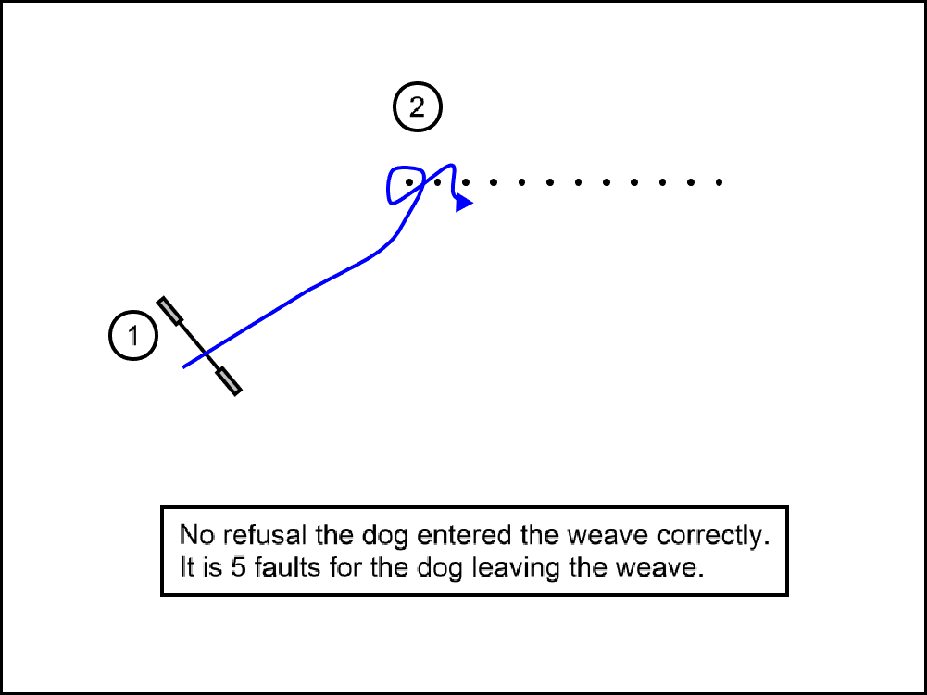

example 3 example 4



**Missed Contacts versus refusals**

* **For the A-frame and Dogwalk:** Leaving the obstacle prior to beginning descent of the down ramp—defined as the dog touching the down ramp with *any* portion of his body—shall constitute a refusal. If the dog touches the down ramp and then leaves before touching the contact point, it is a missed contact, *not* a refusal.
* **For the Seesaw:** If the dog leaves the obstacle before the pivot point, a refusal will be incurred. Once the dog passes the pivot point with *any* portion of his body and then leaves before touching the contact point, it is a missed contact, *not* a refusal. Leaving the obstacle on descent with all four paws before the plank has reached the ground, constitutes a fly-off. If the dog is deemed to leave the plank before it reaches the ground, and misses the contact, this will only constitute one fault.

**Tunnel under contact**

**Tunnel under the A-frame:** If there is a tunnel positioned under the A-frame and the dog runs past the A-frame while attempting that obstacle, and he touches the tunnel with any part of his body or jumps over it while attempting to get on the A-frame, only a refusal fault will be given.

Once the dog is on the A-frame (either on the up ramp or the down ramp), if he jumps or falls off of the obstacle and subsequently touches or jumps over the tunnel, regardless of where the tunnel is positioned under the A-frame, only faults relating to the A-frame performance will be given.

If the dog goes under the A-frame while attempting a tunnel under the contact, it is a refusal fault.

**Tunnel under the Dogwalk:** If there is a tunnel positioned under the dogwalk and the dog runs past the dogwalk while attempting that obstacle, and he touches the tunnel with any part of his body or jumps over it while attempting to get on the dogwalk, only a refusal fault will be given.

Once the dog is on the dogwalk (either on the up ramp, middle ramp, or the down ramp), if he jumps or falls off of the obstacle and subsequently touches or jumps over the tunnel, regardless of where the tunnel is positioned under the dogwalk, only faults relating to the dogwalk performance will be given.

If the dog goes under the dogwalk while attempting a tunnel under the contact, it is a refusal fault.



1. APPENDIX 1: GENERAL AGREEMENT FOR ENTRY TO WAO

General Agreement Acceptance

Through my entry, I declare that I and my Team have read and understand the WAO Official Rules & Regulations (which may be viewed and printed online at http://www.worldagilityopen.com/rules.html), the General Agreement, and the provisions set forth for entry to this event, and I acknowledge that we agree to abide by all such rules, regulations, policies and provisions stipulated therein, including any provisions incorporated by reference.

I accept and agree to abide by any and all rulings of the organising committee relative to matters related to this event.

Waiver of Liability

In consideration of the acceptance of this entry and the opportunity to participate and/or to be judged in the event on the dates to which this entry form applies (the “Event”), I agree to hold harmless each of the parties listed below (including each of their members, officers, directors, agents and employees), hereinafter collectively referred to as the “Event Organisers,” from any claim for loss or injury that may be alleged to have been caused directly or indirectly to any person or thing by the act of myself or the dog listed on the entry form while in or upon the event premises or grounds or near any entrance thereto:

* The event’s local organising committee
* The World Agility Open Championships Organising Committee and their affiliated companies
* Event sponsors
* Property owners of the premises upon which the event is held

I further agree to hold harmless the event organisers from any claim for loss or injury of the dog listed on my entry form for the event as a result of disappearance, theft, death or other act, whether such loss or injury is caused or alleged to be caused for any reason, including negligence. I assume all responsibility and liability for any claims referenced in this “general agreement,” including legal fees.

MEDIA RIGHTS RELEASE

Through the Team's entry, I hereby grant to WAO and its affiliated companies, representatives, agents and assigns, all rights and permission to use or appropriate his/her and their dog’s name, biography, likeness, photograph, voice, performing persona, or other indicia of identity for broadcast, telecast, cablecast, transmission or distribution in any format or media known now or in the future.

Waiver of Rights to Privacy, Publicity, and Personality

Further, I hereby release WAO and its affiliates, representatives, agents and assigns from any claim or cause of action for invasion of the rights of privacy, right of publicity, right of personality, or any similar right.

Electronic Entry Submission

Through my submission of an electronic entry to the event, I acknowledge, accept, and agree to abide by the provisions of this General Agreement, and all policies, rules, regulations, and conditions of entry to the event. Further, if the entry is for a minor, I represent and warrant that I am the parent or legal guardian of the competitor/handler entered in the event, and I acknowledge that I have reviewed all provisions of this General Agreement, policies, rules, regulations, and conditions of entry to the event with the minor and I shall be solely responsible for their actions and compliance with all rules, regulations, policies, and provisions for the event, and assume full liability for minor’s actions and actions of their dog.

Refunds

There shall be no refunds for entries withdrawn after the entry closing date, for absentee handlers or teams, for dismissal from the event as a result of disciplinary action, for dismissal from a class, or for any other reason. Also, no entry fees will be refunded if the event cannot open or be completed by reason of riots, civil disturbances, acts of terrorism, fire, “acts of God,” public emergency, strike, global pandemic, or any other cause beyond the control of WAO.

Class Entry

I understand that if I do not submit the class entry by the closing date specified, the class entry will be made from the information on this Team Entry Form. The first 3 (three) dogs listed on the Entry Details page will be entered into Pentathlon. The next 3 (three) dogs will then be entered in the Biathlon, and the next 3 into Games. Once all dogs have been entered in one class, we will then start again from the top of the list.

1. APPENDIX 2: QUICK REFERENCE TABLES

**JUMP HEIGHT & A-FRAME HEIGHT TABLE**

|  |  |  |  |  |  |  |
| --- | --- | --- | --- | --- | --- | --- |
| Jump height NAME | Dog Height at withers | Jump Height | A-Frame Height | Ascending Spread LENGTH * | Long Jump Length | TYre Height at centER |
| **250** | 320mm & under | 250mm | 1.7m | 215-235mm | 500mm  2 boards | 400mm |
| **300** | 380mm & under | 300mm | 1.7m | 260-280mm | 600mm  2 boards | 450mm |
| **400** | 440mm & under | 400mm | 1.7m | 350-370mm | 800mm  3 boards | 550mm |
| **500** | 500mm & under | 500mm | 1.7m | 440-460mm | 1000mm  4 boards | 650mm |
| **600** | Over 500mm | 600mm | 1.7m | 530-550mm | 1200mm  5 boards | 750mm |

--------------------------------------------------------------------------------------------------------------------------------------

**ASCENDING SPREAD JUMPS**

|  |  |  |  |
| --- | --- | --- | --- |
| **JUMP HEIGHT** | **FRONT BAR HEIGHT** | **BACK BAR HEIGHT** | **LENGTH** Measured from front of front bar to back of back bar |
| 250 | 200 | 250 | 215-235mm |
| 300 | 200 | 300 | 260-280mm |
| 400 | 300 | 400 | 350-370mm |
| 500 | 400 | 500 | 440-460mm |
| 600 | 500 | 600 | 530-550mm |

--------------------------------------------------------------------------------------------------------------------------------------

**DOGWALK CENTER PLANK HEIGHT:** 120cm measured from ground to top of plank

**HEIGHT OF CENTER OF SEESAW PLANK:** 60cm measured from ground to top of plank

**GAMBLERS OBSTACLE POINTS**

|  |  |
| --- | --- |
| POINTS | OBSTACLE |
| 1 point | Jumps |
| 2 points | Tunnels Tyre Long Jump Spread Jumps  Wall Jump |
| 3 points | Seesaw 6 weave poles |
| 4 points | A-frame |
| 5 points | Dogwalk 12 weave poles |